**PROJECT OVERVIEW**

1. Introduction
2. Project framework
3. Host Organization
4. Issues
5. Project description
6. Software development methodology
7. Organization of the report

**PROJECT OVERVIEW**

1. **Introduction**

In this chapter, we present the context in which our work takes place. In fact, we describe the general framework of the project and the place of training that proposed it. At first, we give a presentation of the project. Then, we focus on the methodology followed and the modeling language used. Finally, we present the organization of our report.

1. **Project framework**

This project is part of our graduation project at the Higher Institute of Arts and Multimedia (ISAMM), to obtain the bachelor degree in computer science. It consists of developing a website to improve the relationship between students, instructors and administration in the university by using the technology.

1. **Host Organization**

The company ARZEN Group has been established in 2010, providing technology and construction solutions to public sector and private sector.

Founded in 2016, ARZEN Systems is specialized in providing ICT, Software and Hi-Tech technology solutions to public and private sector.

* Specializations: ICT, INTEGRATION, SOFTWARE
* Website: <http://www.arzensystems.com>
* Sector: Information Technology and Services
* Type: Listed company
* Size of the company:11-50 employees
* Founded in: 2016
* The head office: SÖĞÜTÖZÜ CADDESİ NO: 2 KOÇ KULELER BLOK KAT 7 ÇANKAYA ANKARA, 06450 Turkey
* Logo:

1. **Issues**

The evolution in the field of education has become nowadays a challenge through which we can measure the intellectual development of a society. In our days, we need to improve the relation between the students, instructor and administration in the university using the technology.

In fact, as students we thought about solving these problems:

* In case the student didn’t attend the lectures, he cannot be informed about the homework, project, number of attendances left to be eliminate from the course and the exam dates.
* The Student receive his midterm grade after passing the final exam after two months of the end of the semester.
* The student finds a difficulty to contact his instructor or send to him files.
* Sometimes the student is informed about the date of the exams before one day.
* When the student needs to request an attendance letter, he needs to go to administration to apply, then he comes back once more to take it.
* In case the instructor is absent, the student cannot be informed earlier.

Also, the instructors have problems such as:

- Inform student about exam dates, homework, project, lectures notes.

- Contacting students to inform about his attendance, number of attendances left for the student to be eliminate from the course.

* All these problems motivated us to develop a website to help student to find all what they need easily and the instructor to keep in touch with their students.

1. **Project description**

ISAMMDOCs offers rich learning and communication tools to faculty members and students. You can manage several activities such as sharing sources, requesting assignments and Turn it in assignments in which it is possible to check plagiarism, sharing quizzes, sending e-mail and more. Also, you can use gradebook to grade students' academic activities and announce their grades with realizing a website and mobile application.

Develop a website contains all the details written above to inform the students of all the new features of the site through notifications with quick and easy access.

In this way, we could ensure the reliability of the interaction between the students and the instructors.

1. **Software development methodology**

The software development methodology adopted for our project is The **Rational Unified Process** (**RUP**) which is an iterative software development process framework created by the Rational Software Corporation, a division of IBM since 2003. RUP is not a single concrete prescriptive process, but rather an adaptable process framework, intended to be tailored by the development organizations and software project teams that will select the elements of the process that are appropriate for their needs. RUP is a specific implementation of the Unified Process.

The RUP has determined a project life-cycle consisting of four phases. These phases allow the process to be presented at a high level in a similar way. Each phase has one key objective and milestone at the end that denotes the objective being accomplished.

#### **Inception phase**

The primary objective is to scope the system adequately as a basis for validating initial costing and budgets. The project is checked against the following criteria:

* Stakeholder concurrence on scope definition and cost/schedule estimates.
* Requirements understanding as evidenced by the fidelity of the primary use cases.
* Credibility of the cost/schedule estimates, priorities, risks, and development process.
* Depth and breadth of any architectural prototype that was developed.
* Establishing a baseline by which to compare actual expenditures versus planned expenditures.

#### **Elaboration phase**

The primary objective is to mitigate the key risk items identified by analyzing it up to the end of this phase. The elaboration phase is where the project starts to take shape. In this phase, the problem domain analysis is made and the architecture of the project gets its basic form.

The outcome of the elaboration phase is:

* A use-case model in which the use-cases and the actors have been identified and most of the use-case descriptions are developed.
* A description of the software architecture in a software system development process.
* An executable architecture that realizes architecturally significant use cases.
* Business case and risk list which are revised.
* A development plan for the overall project.

#### **Construction phase**

The primary objective is to build the software system. In this phase, the focus is on the development of components and other features of the system. This is the phase when the bulk of the coding takes place. In larger projects, several construction iterations may be developed to divide the use cases into manageable segments that produce demonstrable prototypes.

This phase produces the first external release of the software. Its conclusion is marked by the initial operational capability milestone.

#### **Transition phase**

The primary objective is to 'transit' the system from development into production, making it available to and understood by the end user. The activities of this phase include training the end users and maintainers and beta testing the system to validate it against the end users' expectations. The system also goes through an evaluation phase, any developer which is not producing the required work is replaced or removed. The product is also checked against the quality level set in the Inception phase.

If all objectives are met, the product release milestone is reached and the development cycle is finished.

1. **Organization of the report**

To make the report more understandable and clear, we chose to subdivide it according to the phases of the software development methodology Rational Unified Process

The first chapter entitled "Preliminary study" was devoted for the analysis of existing project which concerns to analyze two websites of universities graphically and technically.

In the second chapter entitled "Inception phase", we will begin to understand the context and remove the ambiguity about the needs and model them through a model of use cases. Then, we will define the functional and non-functional requirement specifications, identification of actors, assign of priorities and refine the high priority of use cases.

After understanding the requirements of the system, in the third chapter entitled "Elaboration Phase", we will present the work environment, continuing the refinement and design the medium Priority use cases and presenting some prototypes of the interfaces created.

In the fourth chapter called "Construction Phase", we will capture all the remaining needs by continuing the refinement and design the low Priority use cases.

In the fifth chapter called "Transition Phase" we will cite the problems encountered with hosting and show the user interfaces in the form of screenshots.

**CHAPTER 1: Preliminary study**

1. Introduction
2. Analyses of CENG website
3. Analyses of ESPRIT website
4. Synthesis
5. Conclusion

**Chapter 1: Preliminary study**

1. **Introduction**

To better understand the project, we will analyze two similar applications, identify weak points to avoid them and get inspiration from the strengths points. For that, we chose two websites titled as follows:

<< CENG >> Computer Engineering department website of Middle East Technical University in Turkey. << Esprit >>The Private Graduate School of Engineering and Technology in Tunisia.

1. **Analyses of CENG website [cow.ceng.metu.edu.tr]**
2. **Introduction:**

The Computer Engineering Department was seeded back in 1967, as a service department to teach courses in computer science discipline to other academic departments in Middle East Technical University (METU). In 1977, the department was integrated into the Faculty of Engineering with the current name of “Computer Engineering Department”, delegated the new mission of providing degree programs of its own.

Most of the courses require the students to implement their projects and home works on modern operating systems.

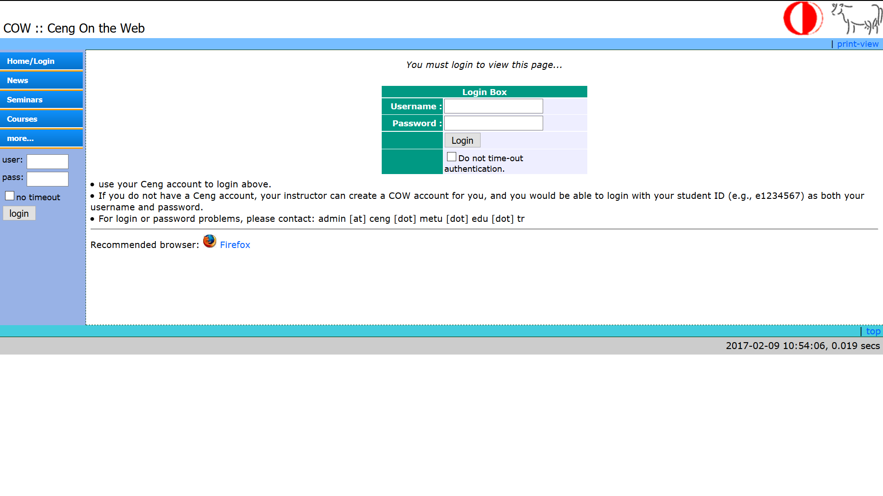The Figure1 below presents a screenshot of the homepage of Computer Engineering Department of Middle East Technical University Ankara Turkey website, through which you can visualize the structure, the shapes and the colors used to start the Graphical analysis.

**Figure1: Homepage of COW METU**

1. **Graphical analysis**

To better organize the graphical analysis part, we have drawn up the following table1, through which we spoke about the structure, the range of shapes, the range of colors, the typographical choice as well as the interactivity.

|  |  |
| --- | --- |
| Structure | Header:Containing the name of the website in the left. The logo of the university and the logo of the computer engineering department in the upper right corner.  Body:Containing menu bar in the left and a login box with four lines of text in the middle.  Footer: Containing a time clock in the right. |
| Range of shapes | A composition based on simple rectangular shapes used to structure and organize the elements in the interface. |
| Range of colors | COW uses the blue color  in the hypertext links and in the separation of parts of the webpage. With the presence of white as background color |
| Typographic Choice | The choice of a simple typography: Arial without serif for all the text in the web pages |
| Links | Using of three types of links:  Text, button and pictures(Logos)  These links facilitate the user navigation. |

Table 1 : Analysais of COW

1. **Technicalanalysais**

The graphic aspect and the appearance have a primordial role to attract the attention of the surfer and encourage him to navigate in the site, without forgetting the technical part which informs us about the not visible details that can cause several problems.

* **Size of pages**

The size of the homepage is 20.8 KB, this size does not exceed 50 KB recommended, so it allows a better referencing.

* **Redirection www (301)**

The URL <<cow.ceng.metu.edu.tr>>does not redirect to <<www.cow.ceng.metu.edu.tr/index.php>>

* **Domain name**

The length of the domain name is 20 characters, the domain name, **http://cow.ceng.metu.edu.tr**/ is difficult to memorize it.

* **Compatibility with web browsers**

The website is compatible with all browser versions, even older ones.

* **Encoding (charset)**

The charset used is UTF-8, this charset is the preferred encoding for e-mail and web pages, minimizes problems related to the display.

* **Meta Tag**

Several meta tags are identified in this website, these tags promote the indexing and referencing of the website.

* **Title**

<<COW::CENGOnTheWebsite>>: 21 characters.

The title of the page is important to reference the website using the abbreviation of the name of the department. It would be preferable to write it completely.

* **Heading**

The home page does not contain any heading.

* **Multimedia content**

The home page contains only two pictures (METU logo and CENG logo**).** Which can make loading page faster.

* **Scripts**

The home page contains references to other pages contains “CSS” style, but the source code is homogeneous because of the presence of the "JavaScript" scripts in the same page.

1. **Critical thinking**

We will criticize the “cow.ceng.metu” website by showing the strengths and the weaknesses.

* **Key strengths:**
* Presence of a graphic charter applied throughout the website.
* Easy to navigate.
* Reference to METU website.
* Readable text.
* **Weaknesses:**
* No search box.
* The choice of colors has no relation with the logo.
* Footer does not contain anything important.

1. **Analyses of ESPRIT website [esprit-tn.com]**
2. **Introduction:**

The Private Graduate School of Engineering and Technology or ESPRIT is a private engineering school in Tunisia based in Ariana and approved by the Ministry of Higher Education and Scientific Research, founded in 2003 at the initiative of three academics who have led numerous projects in Tunisian higher education, and particularly in higher technical education. Surrounded by dozens of their colleagues, as well as ICT companies and financial partners, Esprit has from the start set up courses based on intangible values.

.

The figure2 below shows a screenshot of the homepage of the ESPRIT electronic magazine, through which you can visualize the structure, the shapes and the colors used so that you can begin the graphical analysis.

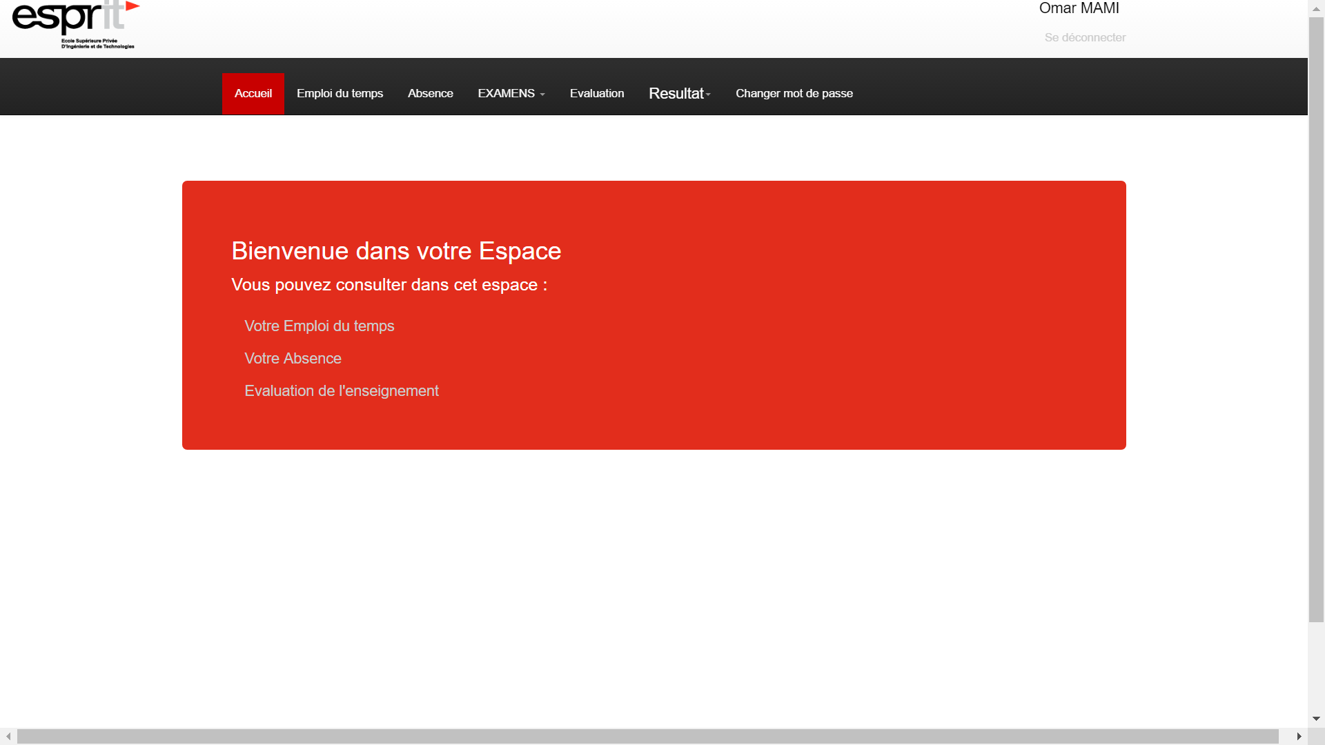

**Figure2: Homepage of the ESPRIT electronic magazine**

1. **Graphical analysis**

To better organize the graphical analysis part, we have drawn up the following table2, through which we spoke about the structure, the range of shapes, the range of colors, the typographical choice as well as the interactivity.

|  |  |
| --- | --- |
| Structure | Header: Containing the menu bar  Body: Containing the spaces that the student can consult  Footer : empty |
| Range of shapes | A composition based on simple geometric shapes used to structure and organize the elements of the interface. |
| Range of colors | A composition based on simple geometric shapes is very basic which serve to structure and organize the elements of the interface.  The red used by ESPRIT is:  #E22D1C:  For the rest of the colors:   * black for the menus with a white writing   #000000 :   * The "white" value for the background   #FFFFFF |
| Typographic Choice | We note the presence of a single typography, to note: Helvetica  Whose sizes vary according to the importance of the content.  -Presence of bold in menus and titles |
| Interactivity | -The logo is a button that leads to the home page  → Easy redirection |

Table 2 : Analysais of ESPRIT

1. **Technical analysis**

The graphic aspect and the appearance have a primordial role to attract the attention of the surfer and encourage him to navigate in the site, without forgetting the technical part which informs us about the not visible details that can cause several problems.

* **Size of pages:**

The size of the homepage is 39.8 KB; this size does not exceed 50 KO recommended.

* **Redirection www**

The URL << esprit-tn.com >> redirect to << www.esprit-tn.com >>

* **Domain name**

The domain name has a length of 13 characters, so the domain name, “<http://www.esprit->tn.com” can be memorized quickly and easily

* **Compatibility with web browsers**

The site is compatible with all browser versions, even older ones.

* **Encoding (charset)**

The charset used is UTF-8, indeed this charset minimizes problems related to the display.

* **Heading**

The home page contains, 1 occurrences H2 and 1 occurrences H3, 4 Occurrences of H4 and 6 occurrences H5.

The use of grade titles in the site is excessive.

* **Multimedia content**

The home page doesn’t contain any image, which can make loading page faster.

* **Scripts**

The homepage contains references to other pages contains "CSS" style, but the source code is homogeneous because of the presence of "JavaScript" scripts on the same page.

1. **Critical thinking**

We will criticize the "esprit-tn" website by highlighting the strengths and weaknesses.

* **Key strengths:**
* Presence of a graphic applied across the end of the website logo
* The site has a size adapted to the screen.
* The site is easily displayed on all browsers (The site is displayed in a unique way on all browsers, Example: Interne Explore, Make Fox, Google Chrome).
* The site has excellent compatibility
* The home page of the site is displayed quickly
* The menu is easily identifiable on the website

- The menu is always readable on the screen

- The headings are easily identifiable and explicit

- The number of main items in the menu is selected

- Information is found in less than 3 clicks

* The links of the site work perfectly

* Note: The site does not contain links to other company sites that operate in the same industry as PragmaCom. It is essential to create an external links that will have a positive impact in improving the positioning of the site in the search engines. So, if we use this tool, we will improve the natural referencing of the site of the company.

* **Weaknesses:**
* Empty footer
* Content is not regularly updated
* The site lacks interactive spaces (forums, chat, etc.)
* The site does not contain banners
* No search box.
* No picture and flash animations

## Synthesis

To achieve a product with higher quality, we made a technical and graphical analysis for two universities websites. Thus, we have taken the strengths, which we intend to improve, and the weak points that we will avoid. For that, we will work for an easy navigation, referencing to the official ISAMM website, a simple structuring of the pages and a readable text. We will avoid the wrong color choice, empty footer, lacking interactive spaces. This site will be for all students and instructors of ISAMM.

1. **Conclusion**

In this chapter, we have analyzed the existing project, in the next chapter we will move to the incubation phase to determine the use cases, define the actors and assign the priorities for each case. And we will refine the priority of use cases.

**CHAPTER 2: INCEPTION PHASE**

1. Introduction
2. Choice of modeling language
3. Functional requirement specifications
4. Non-functional requirement specifications
5. Refinement of high priority use cases
6. Use cases diagram of high priority after refinement
7. Technical analysis
8. Software architectural pattern
9. Conclusion

**CHAPTER 2: INCEPTION PHASE**

1. **Introduction**

The first phase of the software development methodology Rational Unified Process consists of presenting the actors, identifying the use cases and use case diagrams. Furthermore, we will draw up the table of priorities and finally we will deal with high priority of use cases.

1. **Choice of modeling language**

A modeling language is any artificial language that can be used to express within a structure that is defined by a consistent set of rules.

We chose UML Unified Modeling Language (UML) as an object-oriented modeling language to provide a standard way to visualize the design of a system based on classes, inheritance, and messages.

1. **Functional requirement specifications**

This part composes of three parts. First, we will introduce the actors and the use cases. Second, we will draw up a table in which each case will be attributed to an actor and a priority. Third, we will model the global use cases diagram.

1. **Actors identification**

An actor is an external entity interacts with the system and accomplishes the needed functionalities

For our website, we identified three actors:

* **Administrator:** manages the contents of the website.
* **Student:** has an account. He can deposit and consult documents.
* **Instructor:** has an account. He can deposit documents and share news.

**Note:** We identified student and instructor independently because they don’t have the same functionalities**.**

1. **Use cases identification**

In the following, we will present the different functionalities attributed to each user.

* **Administrator functionalities:**
* Authentication: The administrator must log in by inserting his ID number and password to get access to his space.
* Manage students: Affect students to the necessary courses.
* Manage instructors: Affect instructor to his groups and courses.
* The administrator can delete or modify the documents posted by the students or the instructors.
* Notify the student or the instructor about the news: the administrator posts the news to the members registered.
* Validate or reject the attendance letter request from the student.
* Validate or reject the club event request from the student.
* Send private messages to the instructors and students.
* **Student functionalities:**
* Authentication: The student must log in by inserting his/her ID number and password to access his/ her account.
* Consult documents:
* Download lecture notes.
* Download home works and projects announcement.
* Check grades.
* Check news from the instructors or the administration.
* Check midterms and exams dates.
* Check the number of attendance left to be eliminated.
* Check events.
* Submit home works and projects.
* Add new discussion topic in discussion forum, delete it or comment the posts of other students.
* Send a private message to the instructors, students and the administration.
* Request an attendance letter from the administration.
* Manage club event:
* Request for club events creation by specifying the club name, date of the event, the location and brief description.
* Modify event.
* Delete event.
* Evaluate the course and the instructor of each course by filling in an evaluation document posted by the administration in the end of the semester.
* **Instructor functionalities:**
* Authentication: The instructor must login by inserting his ID number and password to access his account.
* Manage documents:
* Upload lectures notes.
* Upload home works announcement.
* Upload projects announcement.
* Share news
* Share student’s grades.
* Share midterms and exams dates.
* Share general news and announcement.
* Consult the home works and projects and the news topics submitted by the students.
* Send a private message to the instructors, students and the administration.
* Evaluate the courses that he is teaching, by filling in an evaluation document posted by the administration in the end of the semester.

1. **Categorization of cases by priority**

After identifying the actors and assigning them the use cases. Now, we will categorize them by priority to be able to refine them later. The Table 3 shows the cases grouped by priority.

|  |  |  |  |  |
| --- | --- | --- | --- | --- |
| Actor | | Use cases | | Priority |
| Administrator | | Manage member | | - Add new member.  - Delete member. | **HIGH** |
| Manage course | | -Add new course.  -Delete course. | **HIGH** |
| Manage news | | - Post new announcement.  - Modify announcement.  - Delete announcement. | **HIGH** |
| Manage event | | - Post new event.  - Modify event.  - Delete event. | **MEDIUM** |
| Check attendance letter request | | - Accept attendance letter request.  - Reject attendance letter request. | **MEDIUM** |
| Check student event request | | - Accept student event request.  - Reject student event request. | **MEDIUM** |
| Send private message | |  | **MEDIUM** |
| Consult document | | **-** Download lecture note.  - Download homework announcement.  - Download project announcement. | **LOW** |
| Upload document | | - Upload lecture note.  - Upload homework announcement.  - Upload project announcement. | **LOW** |
| Update profile | |  | **LOW** |
| Student | | Consult document | | **-** Download lecture note.  - Download practical work (TD).  - Download homework announcement.  - Download project announcement. | **HIGH** |
| Submit document | | - Submit homework.  - Submit project. | **HIGH** |
| Check course components | | - Check grades.  - Check midterm and exam dates.  - Check attendance. | **HIGH** |
| Manage discussion forum | | - Post new discussion topic.  - Delete discussion topic.  - Comment discussion topic. | **MEDIUM** |
| Check news | | - Check administrative announcement.  - Check event. | **MEDIUM** |
| Manage event | | - Request new event.  - Modify event.  - Delete event. | **MEDIUM** |
| Request attendance lettre | |  | **MEDIUM** |
| Update profile | |  | **LOW** |
| Send private message | |  | **LOW** |
| Instructor | | Upload document | | - Upload lecture note.  - Upload practical work (TD).  - Upload homework announcement.  - Upload project announcement. | **HIGH** |
| Consult submitted document | | - Check student homework.  - Check student project. | **HIGH** |
| Post course components | | - Post student grades.  -Post midterm and exam dates.  - Post attendance. | **HIGH** |
| Manage discussion forum | | - Post new discussion topic.  - Delete discussion topic.  - Comment discussion topic. | **MEDIUM** |
| Check news | | - Check administrative announcement.  - Check event. | **MEDIUM** |
| Check attendance letter request as supervisor | | - Accept attendance letter request.  - Reject attendance letter request. | **MEDIUM** |
| Check student event request as supervisor | | - Accept student event request.  - Reject student event request. | **MEDIUM** |
| Update profile | |  | **LOW** |
| Send private message | |  | **LOW** |

**Table3: Categorizing use cases by priority**

1. **The global use cases diagram**

In this part, we will cite only the general functionalities discussed in the initial phase. We describe through the following diagram the global functionalities targeted by our application. Our application is based on three actors who interact with the system.

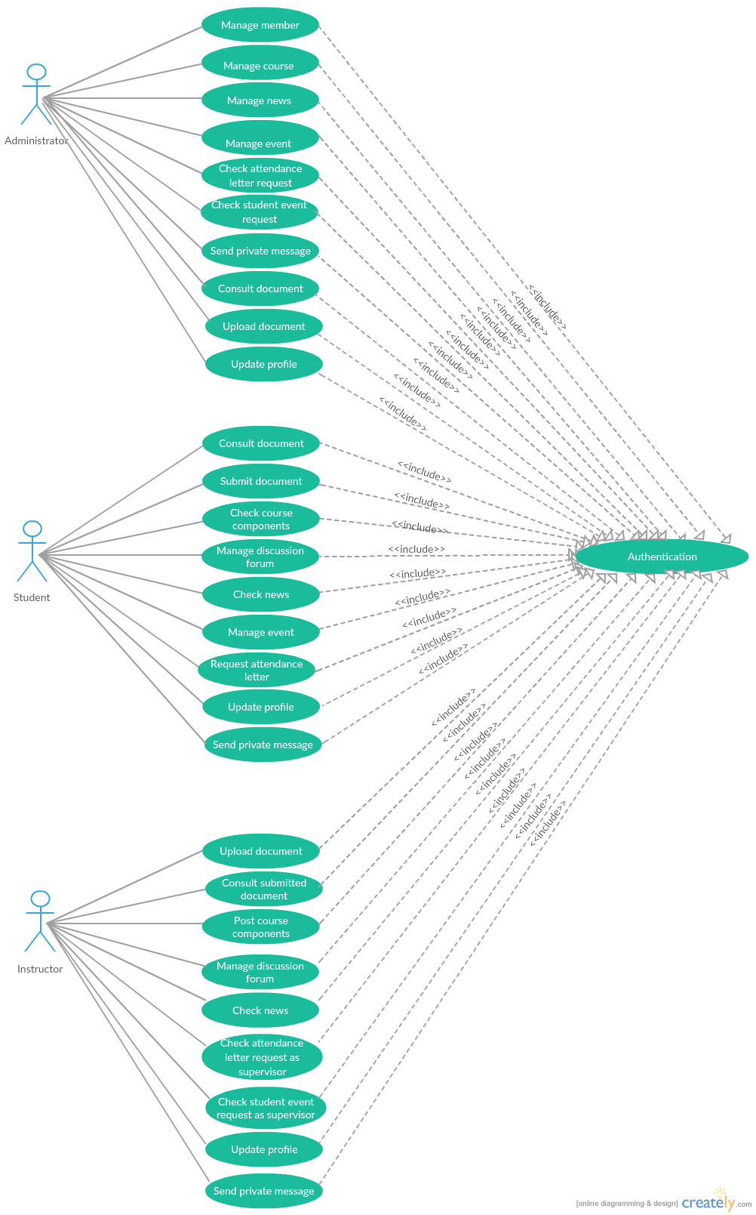

1. **Non-functional requirement specifications**

* Ensure data confidentiality to secure the personal user information.
* Speed of processing by sending notifications immediately to the users.
* The program should be user friendly and aesthetically pleasing.
* Program instructions should easy to understand, abstract but clear.
* Easy to use interface, which is useable and visually attractive.

1. **Refinement of high priority use cases**

In the following, we will refine the use cases of high priority, model each case with a use cases diagram and write the use case definition.

1. **Refine the use case *Manage member***

* **The use case diagram**

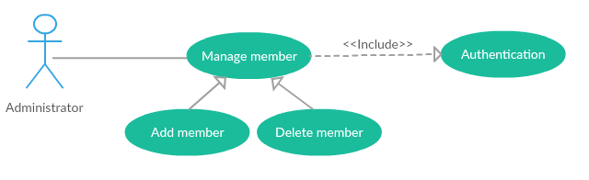

* **The use case definition of the child *Add new member***

|  |  |
| --- | --- |
| **Use Case Name:** | Add new member |
| **Actor:** | Administrator |
| **Description:** | Administrator could add a new member to the system. |
| **Preconditions:** | Administrator identity has been authenticated |
| **Post conditions:** | Added member |
| **Priority:** | HIGH |
| **Normal Course of Events:** | * The administrator clicks on the “Add member” button. * The system displays the adding member registration form. * The administrator completes the form which contains: the first name, last name, national identity number, the registration number, the gender of the applicant, and the position of the member (Student, instructor, another administrator…). * If the applicant is a student: The administrator needs to affect his level, category, and his group number. * The administrator clicks on Create button. * The system checks the fields, add the member in the database and displays a success message. |
| **Exceptions:** | An error message will be displayed if the administrator does not complete all the required fields. |

**Table 4: The use case definition of the child *Add new member***

* **The use case definition of the child *Delete member***

|  |  |
| --- | --- |
| **Use Case Name:** | Delete member |
| **Actor:** | Administrator |
| **Description:** | Administrator could delete a member from the system. |
| **Preconditions:** | Administrator identity has been authenticated |
| **Post conditions:** | Deleted member |
| **Priority:** | HIGH |
| **Normal Course of Events:** | * The administrator clicks on “Members” button. * The system displays the list of all members categorized by position. * The administrator clicks on the Delete icon next to the member row. * The system deletes the member from the database and displays a success message. |

**Table 5: The use case definition of the child *Delete member***

1. **Refine the use case *Manage course***

* **The use case diagram**

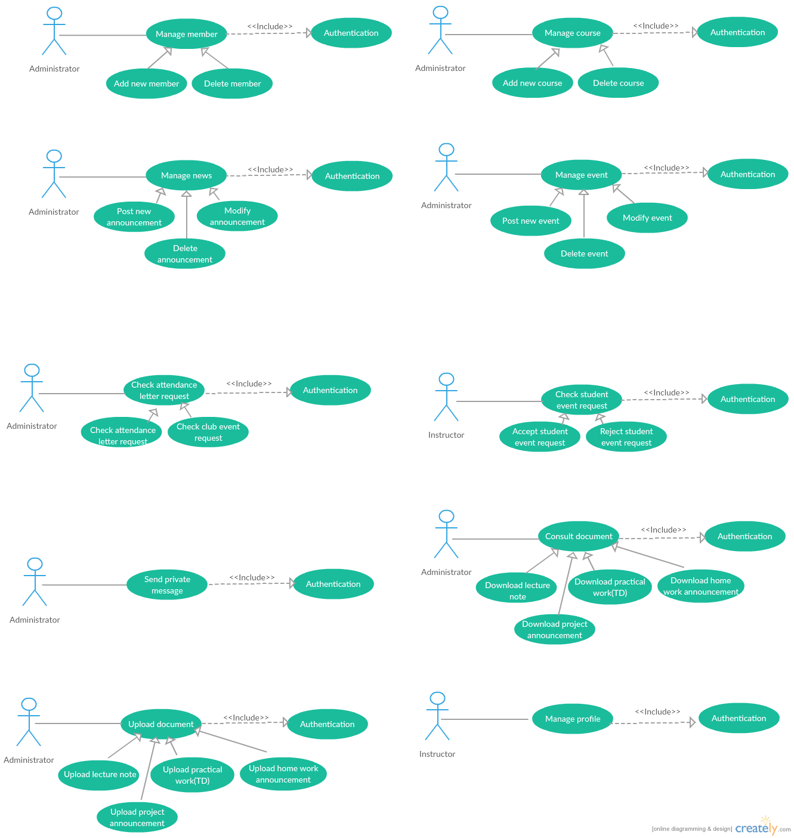

* **The use case definition of the child *Add new course***

|  |  |
| --- | --- |
| **Use Case Name:** | Add new course |
| **Actor:** | Administrator |
| **Description:** | Administrator could add new course to the system. |
| **Preconditions:** | Administrator identity has been authenticated |
| **Post conditions:** | Added course |
| **Priority:** | HIGH |
| **Normal Course of Events:** | * The administrator clicks on “Add course” button*.* * The system displays the adding member form. * The administrator completes a form which contains: the course full name, the course code, a brief description, the level, the category, the course review system, and the total number of absences allowed. * The administrator clicks on the Create button. * The system checks the fields, add the course in the database, and displays a success message. |
| **Exceptions:** | An error message will be displayed if the administrator does not complete all the required fields. |

**Table 6: The use case definition of the child *Add new course***

* **The use case definition of the child *Delete course***

|  |  |
| --- | --- |
| **Use Case Name:** | Delete course |
| **Actor:** | Administrator |
| **Description:** | Administrator could delete a course from the system. |
| **Preconditions:** | Administrator identity has been authenticated |
| **Post conditions:** | Deleted course |
| **Priority:** | HIGH |
| **Normal Course of Events:** | * The administrator clicks on the “Courses” button*.* * The system display the list of all courses. * The administrator clicks on the Delete icon next to the course row. * The system deletes the course from the database and displays a success message. |

**Table 7: The use case definition of the child *Delete course***

1. **Refine the use case *Manage news***

* **The use case diagram**



* **The use case definition of the child *Post new announcement***

|  |  |
| --- | --- |
| **Use Case Name:** | Post new announcement |
| **Actor:** | Administrator |
| **Description:** | The Administrator could post announcement addressed to all the members, or to a specific level/category. |
| **Preconditions:** | Administrator identity has been authenticated |
| **Post conditions:** | Posted announcement |
| **Priority:** | HIGH |
| **Normal Course of Events:** | * The administrator clicks on the “New announcement” button. * The system displays the “adding post” form. * The administrator completes a form which contains the subject, the content, and the receiver fields. * The administrator clicks on the Create button. * The system adds the new announcement in the database and displays a success message. |
| **Exceptions:** | An error message will be displayed if the instructor does not complete all the required fields. |

**Table 8: The use case definition of the child *Post new announcement***

* **The use case definition of the child *Modify announcement***

|  |  |
| --- | --- |
| **Use Case Name:** | Modify announcement |
| **Actor:** | Administrator |
| **Description:** | Administrator could modify posted announcement. |
| **Preconditions:** | Administrator identity has been authenticated and the announcement has been posted. |
| **Post conditions:** | Modified announcement |
| **Priority:** | HIGH |
| **Normal Course of Events:** | * The administrator clicks on the News button. * The system displays a list of all announcements. * The administrator clicks on the Modify icon. * The system displays the original content of the post. * The administrator can modify the fields. * The administrator clicks on the Modify button next to the announcement. * The system modifies the announcement in the database and displays a success message. |
| **Exceptions:** | An error message will be displayed if the instructor does not complete all the required fields. |

**Table 9: The use case definition of the child *Modify announcement***

* **The use case definition of the child *Delete announcement***

|  |  |
| --- | --- |
| **Use Case Name:** | Delete announcement |
| **Actor:** | Administrator |
| **Description:** | Administrator could delete posted announcement. |
| **Preconditions:** | Administrator identity has been authenticated and announcement has been posted. |
| **Post conditions:** | Deleted announcement |
| **Priority:** | HIGH |
| **Normal Course of Events:** | * The administrator clicks on the “News” button. * The system displays the list of all announcements. * The administrator clicks on the Delete icon next to the announcement. * The system deletes the announcement from the database and displays a success message. |

**Table 10: The use case definition of the child *Delete announcement***

1. **Refine the use case *Consult document***

* 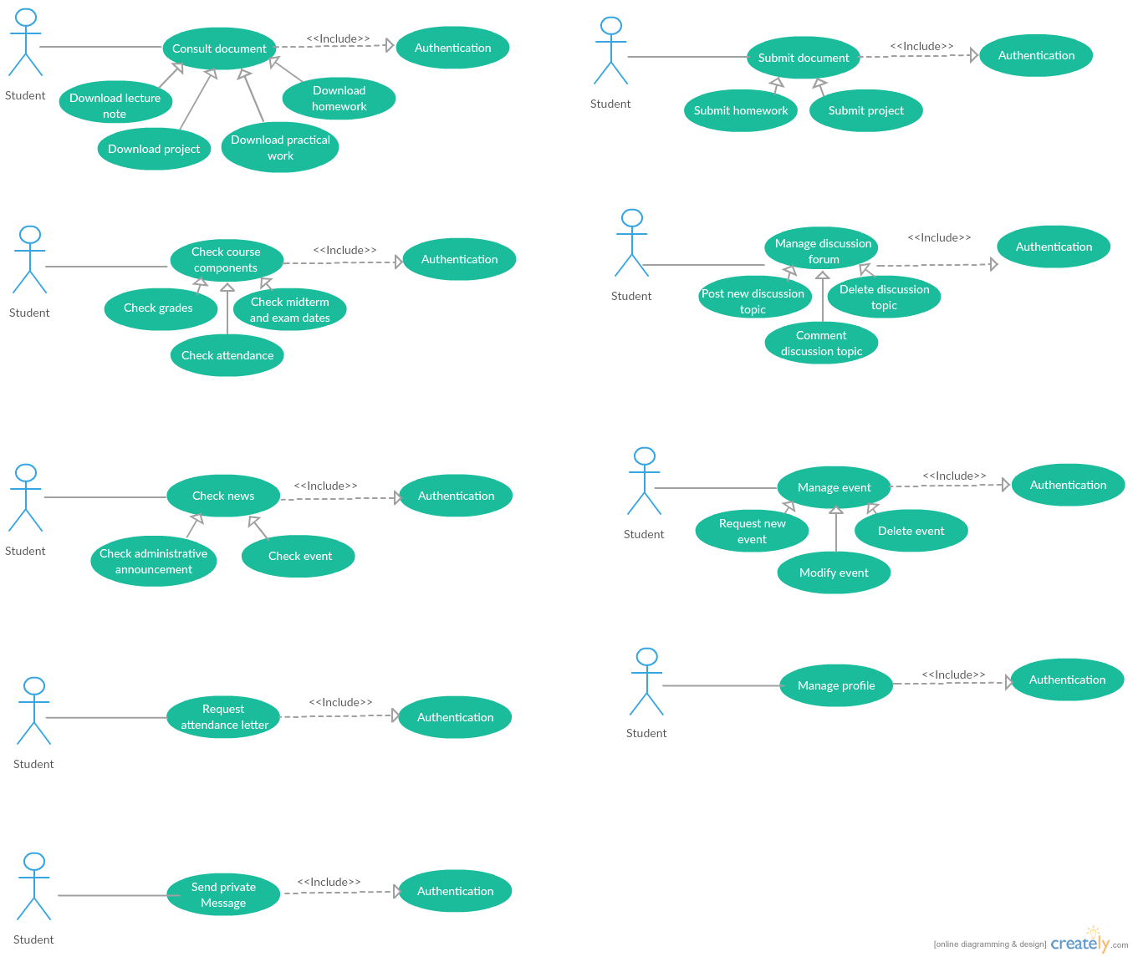**The use case diagram**
* **The use case definition of the child *Download lecture note***

|  |  |
| --- | --- |
| **Use Case Name:** | Download lecture note |
| **Actor:** | Student |
| **Description:** | Student could download lecture notes. |
| **Preconditions:** | Student identity has been authenticated. |
| **Post conditions:** | Downloaded lecture note |
| **Priority:** | HIGH |
| **Normal Course of Events:** | * The student clicks on the name of the course. * The system displays the course webpage. * The student clicks on the Lecture notes webpage. * The system displays all the existing lecture notes related to the course. * The student clicks on the download icon located next to the lecture note row. |

**Table 11: The use case definition of the child *Download lecture note***

* **The use case definition of the child *Download practical work (TD)***

|  |  |
| --- | --- |
| **Use Case Name:** | Download practical work (TD) |
| **Actor:** | Student |
| **Description:** | Student could download practical work. |
| **Preconditions:** | Student identity has been authenticated. |
| **Post conditions:** | Downloaded practical work |
| **Priority:** | HIGH |
| **Normal Course of Events:** | * The student clicks on the name of the course. * The system displays the course webpage. * The student clicks on the Lecture notes webpage. * The system displays all the existing lecture note related to the course. * The student clicks on the name of the lecture note. * The system displays the list of all the practical work related to a specific lecture note. * The student clicks on the name of the addressed practical work. |

**Table 12: The use case definition of the child *Download practical work (TD)***

* **The use case definition of the child *Download homework announcement***

|  |  |
| --- | --- |
| **Use Case Name:** | Download homework announcement |
| **Actor:** | Student |
| **Description:** | Student could download homework announcement. |
| **Preconditions:** | Student identity has been authenticated. |
| **Post conditions:** | Downloaded homework announcement |
| **Priority:** | HIGH |
| **Normal Course of Events:** | * The student clicks on the name of the course. * The system displays the course webpage. * The student clicks on the Homework webpage. * The system displays all the existing home works related to the course. * The student clicks on the download icon in next to the homework announcement row. |

**Table 13: The use case definition of the child *Download homework announcement***

* **The use case definition of the child *Download project announcement***

|  |  |
| --- | --- |
| **Use Case Name:** | Download project announcement |
| **Actor:** | Student |
| **Description:** | Student could download the project announcement. |
| **Preconditions:** | Student identity has been authenticated. |
| **Post conditions:** | Downloaded project announcement |
| **Priority:** | HIGH |
| **Normal Course of Events:** | * The student clicks on the name of the course. * The system displays the course webpage. * The student clicks on the project webpage. * The system displays all the existing projects related to the course. * The student clicks on the download icon located next to the project announcement row. |

**Table 14: The use case definition of the child *Download project announcement***

1. **Refine the use case *Submit document***

* **The use case diagram**
* **The use case definition of the child *Submit homework***

|  |  |
| --- | --- |
| **Use Case Name:** | Submit homework |
| **Actor:** | Student |
| **Description:** | Student could submit homework. |
| **Preconditions:** | Student identity has been authenticated. |
| **Post conditions:** | Submitted homework |
| **Priority:** | HIGH |
| **Normal Course of Events:** | * The student clicks on the name of the course. * The system displays the course webpage. * The student clicks on the Homework webpage. * The system displays all the existing homework related to the course. * The student clicks on the homework name. * The system displays the due date, the time remaining, a brief description, and the upload zone to add the document. * The student clicks on the upload document zone and select the file from his computer. * The student clicks on the Post button. * The system adds the homework in the database and displays a success message. |
| **Alternative Courses:** | * The student could change the submitted homework. * The system changes the submitted homework from the database and displays a success message. |

**Table 15: The use case definition of the child *Submit homework***

* **The use case definition of the child *Submit project***

|  |  |
| --- | --- |
| **Use Case Name:** | Submit project |
| **Actor:** | Student |
| **Description:** | Student could submit project. |
| **Preconditions:** | Student identity has been authenticated. |
| **Post conditions:** | Submitted project. |
| **Priority:** | HIGH |
| **Normal Course of Events:** | * The student clicks on the name of the course. * The system displays the course webpage. * The student clicks on the Project webpage. * The system displays all the existing project related to the course. * The student clicks on the project name. * The system displays the due date, the time remaining, a brief description and the upload zone to add the document. * The student clicks on the upload document zone and select the file from his computer. * The student clicks on the Post button. * The system adds the project in the database and displays a success message. |
| **Alternative Courses:** | * The student could change the submitted project. * The system changes the submitted project from the database and displays a success message. |

**Table 16: The use case definition of the child *Submit project***

1. **Refine the use case *Check course components***

* **The use case diagram**
* **The use case definition of the child *Check grades***

|  |  |
| --- | --- |
| **Use Case Name:** | Check grades |
| **Actor:** | Student |
| **Description:** | The Student could check the course grades. |
| **Preconditions:** | Student identity has been authenticated. |
| **Post conditions:** | Checked grade |
| **Priority:** | HIGH |
| **Normal Course of Events:** | * The student clicks on the “Grades” button. * The system displays a list of courses and the related grades of the home works, projects, the midterms, and the final exams. |

**Table 17: The use case definition of the child *Check grades***

* **The use case definition of the child *Check midterm and exam dates***

|  |  |
| --- | --- |
| **Use Case Name:** | Check midterm and exam dates |
| **Actor:** | Student |
| **Description:** | Student could check the midterm and exam dates. |
| **Preconditions:** | Student identity has been authenticated. |
| **Post conditions:** | Checked midterm and exam dates |
| **Priority:** | HIGH |
| **Normal Course of Events:** | * The student clicks on the name of the course. * The system displays the course webpage. * The student clicks on the Exam Dates webpage. * The system displays all the exam dates in the course with a brief description. |

**Table 18: The use case definition of the child *Check midterm and exam dates***

* **The use case definition of the child *Check attendance***

|  |  |
| --- | --- |
| **Use Case Name:** | Check Attendance |
| **Actor:** | Student |
| **Description:** | Student could check how many attendances are left to be eliminated from the course. |
| **Preconditions:** | Student identity has been authenticated. |
| **Post conditions:** | Checked attendance |
| **Priority:** | HIGH |
| **Normal Course of Events:** | * The student clicks on the Attendance button. * The system displays the number of absences in each course over to the total of the allowed absences. |

**Table 19: The use case definition of the child *Check attendance***

1. **Refine the use case *Upload document***

* 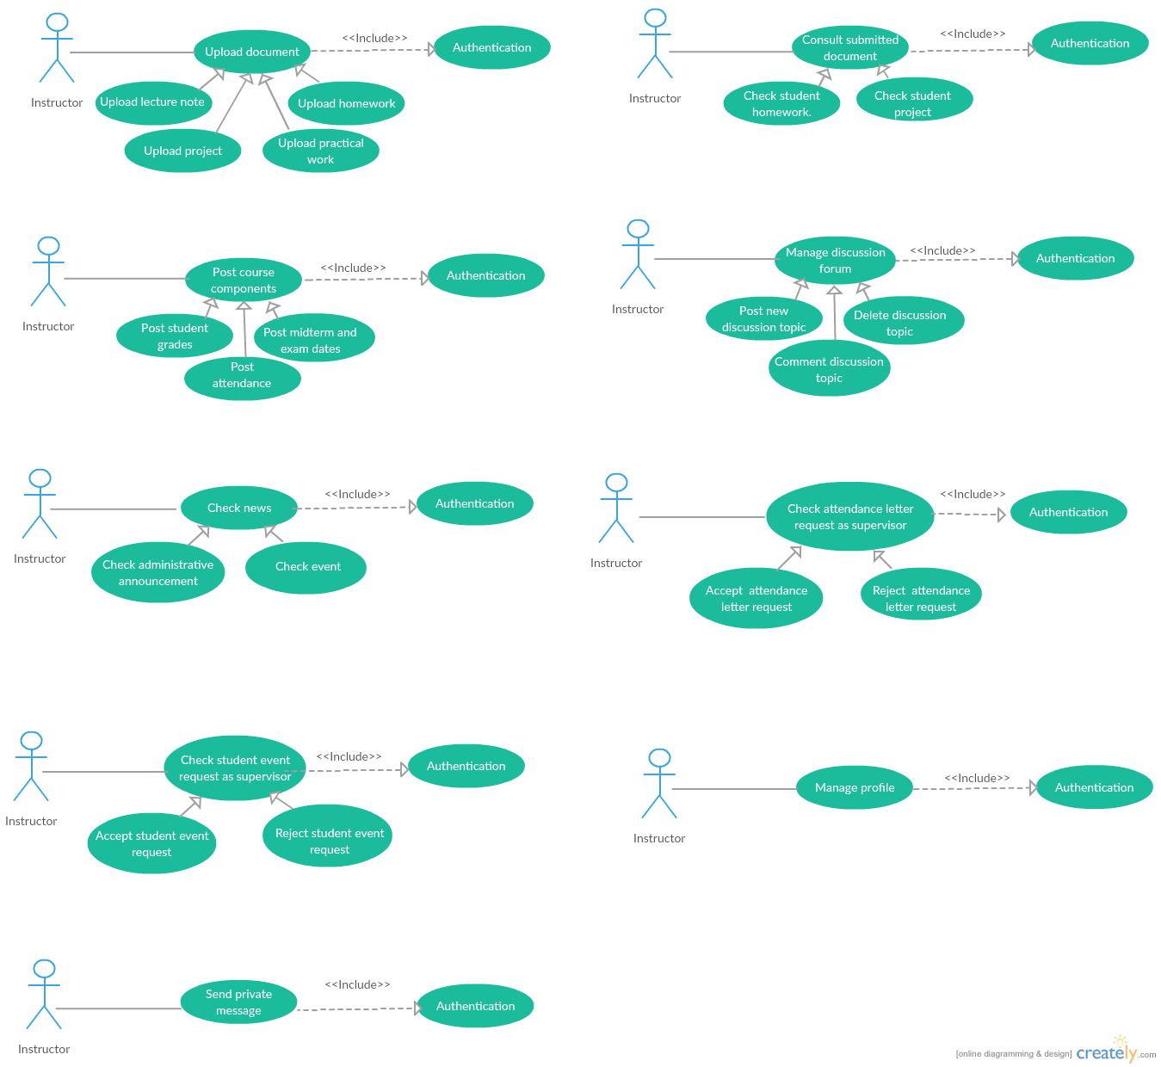**The use case diagram**
* **The use case definition of the child *Upload lecture note***

|  |  |
| --- | --- |
| **Use Case Name:** | Upload lecture note |
| **Actor:** | Instructor |
| **Description:** | Instructor could upload the lecture notes. |
| **Preconditions:** | Instructor identity has been authenticated. |
| **Post conditions:** | Uploaded lecture notes. |
| **Priority:** | HIGH |
| **Normal Course of Events:** | * The instructor clicks on the name of the course. * The system displays the course webpage. * The instructor clicks on the New Document webpage. * The instructor completes a form which contains: the document type (Lecture Note), the title, the content and an optional description. * The instructor clicks on the Submit button. * The system adds the lecture note in the database and displays a success message. |
| **Alternative Courses:** | * The instructor can modify the existing lecture notes. * The instructor can delete the existing lecture notes. |
| **Exceptions:** | An error message will be displayed if the instructor does not complete all the required fields. |

**Table 20: The use case definition of the child *Upload lecture note***

* **The use case definition of the child *Upload practical work (TD)***

|  |  |
| --- | --- |
| **Use Case Name:** | Upload practical work (TD) |
| **Actor:** | Instructor |
| **Description:** | Instructor could upload the practical work |
| **Preconditions:** | Instructor identity has been authenticated. |
| **Post conditions:** | Uploaded practical work. |
| **Priority:** | HIGH |
| **Normal Course of Events:** | * The instructor clicks on the name of the course. * The system displays the course webpage. * The instructor clicks on the Lecture note webpage. * The instructor completes a form which contains an upload zone for the file and an input for the title. * The instructor clicks on the Post button. * The system adds the practical work in the database and displays a success message. |
| **Alternative Courses:** | * The instructor can delete existing practical work. |
| **Exceptions:** | An error message will be displayed if the instructor does not complete all the required fields. |

* **Table 21: The use case definition of the child *Upload practical work (TD)***
* **The use case definition of the child *Upload homework announcement***

|  |  |
| --- | --- |
| **Use Case Name:** | Upload homework announcement |
| **Actor:** | Instructor |
| **Description:** | Instructor could upload the homework announcements. |
| **Preconditions:** | Instructor identity has been authenticated. |
| **Post conditions:** | Uploaded homework announcement. |
| **Priority:** | HIGH |
| **Normal Course of Events:** | * The instructor clicks on the name of the course icon. * The system displays the course webpage. * The instructor clicks on the New Document webpage. * The instructor completes a form which contains: the document type (Homework announcement), the title, the content, an optional description, and the due date. * The instructor clicks on the Submit button. * The system adds the homework announcement in the database and displays a success message. |
| **Alternative Courses:** | * The instructor can modify the existing home works. * The instructor can delete the existing home works. |
| **Exceptions:** | An error message will be displayed if the instructor does not complete all the required fields. |

**Table 22: The use case definition of the child *Upload homework announcement***

* **The use case definition of the child *Upload project announcement***

|  |  |
| --- | --- |
| **Use Case Name:** | Upload project announcement |
| **Actor:** | Instructor |
| **Description:** | Instructor could upload the project announcement. |
| **Preconditions:** | Instructor identity has been authenticated. |
| **Post conditions:** | Uploaded project announcement. |
| **Priority:** | HIGH |
| **Normal Course of Events:** | * The instructor clicks on the name of the course. * The system displays the course webpage. * The instructor clicks on the New Document webpage. * The instructor completes a form which contains the document type (Project announcement), the title, the content, an optional description and the due date. * The instructor clicks on the Submit button. * The system adds the project announcement in the database and displays a success message. |
| **Alternative Courses:** | * The instructor can modify the existing projects. * The instructor can delete the existing projects. |
| **Exceptions:** | An error message will be displayed if the instructor does not fill in all the required fields. |

**Table 23: The use case definition of the child *Upload project announcement***

1. **Refine the use case *Consult submitted document***

* **The use case diagram**
* **The use case definition of the child *Check student homework***

|  |  |
| --- | --- |
| **Use Case Name:** | Check student homework |
| **Actor:** | Instructor |
| **Description:** | Instructor could check the homework submitted by the student. |
| **Preconditions:** | Instructor identity has been authenticated |
| **Post conditions:** | Checked student homework |
| **Priority:** | HIGH |
| **Normal Course of Events:** | * The instructor clicks on the name of the course. * The system displays the course webpage. * The instructor clicks on the Homework webpage. * The system displays the list of the home works. * The instructor clicks on the name of the homework. * The system displays the list of the posting students. * The instructor can download the submitted documents. * The instructor adds/modifies the grades of each student. * The system adds/modifies the grade in the database and displays a success message. |

**Table 24: The use case definition of the child *Check student homework***

* **The use case definition of the child *Check student project***

|  |  |
| --- | --- |
| **Use Case Name:** | Check student project |
| **Actor:** | Instructor |
| **Description:** | Instructor could check the project submitted by the student. |
| **Preconditions:** | Instructor identity has been authenticated |
| **Post conditions:** | Checked student project |
| **Priority:** | HIGH |
| **Normal Course of Events:** | * The instructor clicks on the name of the course. * The system displays the course webpage. * The instructor clicks on the Project webpage. * The system displays the list of the projects published by instructor. * The instructor clicks on the name of the project. * The system displays the list of the posting students. * The instructor can download the submitted documents. * The instructor adds/modifies the grades of each student. * The system adds/modifies the grade in the database and displays a success message. |

**Table 25: The use case definition of the child *Check student project***

1. **Refine the use case *Post course components***

* **The use case diagram**



* **The use case definition of the child *Post student grades***

|  |  |
| --- | --- |
| **Use Case Name:** | Post student grades |
| **Actor:** | Instructor |
| **Description:** | Instructor could post the grade for all his students. |
| **Preconditions:** | Instructor identity has been authenticated |
| **Post conditions:** | Posted grade |
| **Priority:** | HIGH |
| **Normal Course of Events:** | * The instructor clicks on the name of the course. * The system displays the course webpage. * The instructor clicks on the Exam Result webpage for midterms and final exams. * The system displays the list of the groups. * The instructor clicks on the name of the specified group. * The system displays the list of the students. * The instructor adds the grades of each student and clicks on the Post button. * The system adds the grades in the database. Notifies the addressed members and displays a success message. |
| **Alternative Courses:** | * The instructor can modify the grades. |

**Table 26: The use case definition of the child *Post student grades***

* **The use case definition of the child *Post midterm and exam dates***

|  |  |
| --- | --- |
| **Use Case Name:** | Post midterm and exam dates |
| **Actor:** | Instructor |
| **Description:** | Instructor could post the midterm and exam dates. |
| **Preconditions:** | Instructor identity has been authenticated |
| **Post conditions:** | Posted midterm and exam dates |
| **Priority:** | HIGH |
| **Normal Course of Events:** | * The instructor clicks on the name of the course. * The system displays the course webpage. * The instructor posts the exam type, the exam dates, with an optional brief description. * The instructor clicks on the Post button. * The system adds the exam date in the database and displays a success message. |
| **Alternative Courses:** | * The instructor can delete the existing exam dates. |
| **Exceptions:** | An error message will be displayed if the instructor does not fill in all the required fields. |

**Table 27: The use case definition of the child *Post midterm and exam dates***

* **The use case definition of the child Post *attendance***

|  |  |
| --- | --- |
| **Use Case Name:** | Post attendance |
| **Actor:** | Instructor |
| **Description:** | Instructor could post the attendance for each session. |
| **Preconditions:** | Instructor identity has been authenticated |
| **Post conditions:** | Posted attendance |
| **Priority:** | HIGH |
| **Normal Course of Events:** | * The instructor clicks on the name of the course. * The system displays the course webpage. * The instructor clicks on the Attendance webpage. * The system displays the list of the groups. * The instructor clicks on the chosen group. * The system displays the list of the students. * The instructor checks the absent students and clicks on the Post button. * The system adds the attendance in the database. Notifies the addressed members and displays a success message. |

**Table 28: The use case definition of the child Post *attendance***

1. ***Use cases diagram of high priority after refinement***

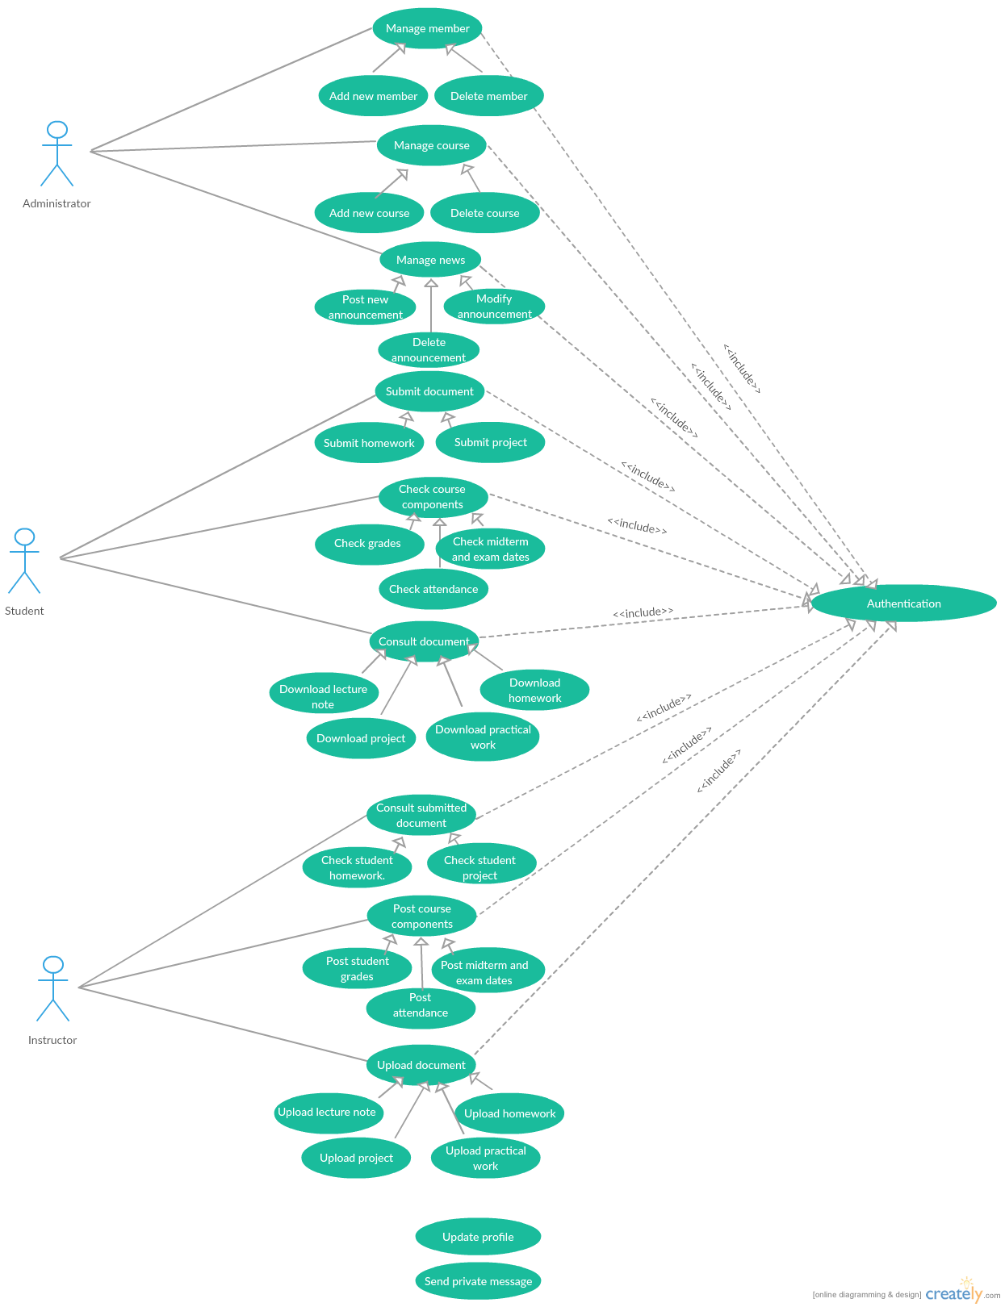The figure below shows the use case diagram after refinement of high priority use cases.

***Figure: Use cases diagram of high priority after refinement***

1. ***Technical analysis***

After refining use cases of high priority, we will move on to technical analysis.

In the following we will present the class and sequences diagrams associated to each use case and model their interfaces and their controllers.

1. **Analysis of the use case *Manage member***

In order to model the use case “*Manage member”*. in first order, we used a class diagram which presents two interfaces, two controllers and one entity class, to illustrate the interaction between them we will present a detailed sequence diagram.

1. **Class diagram of the use case *Manage member***

The following figure presents the class diagram of the use case *Manage member*

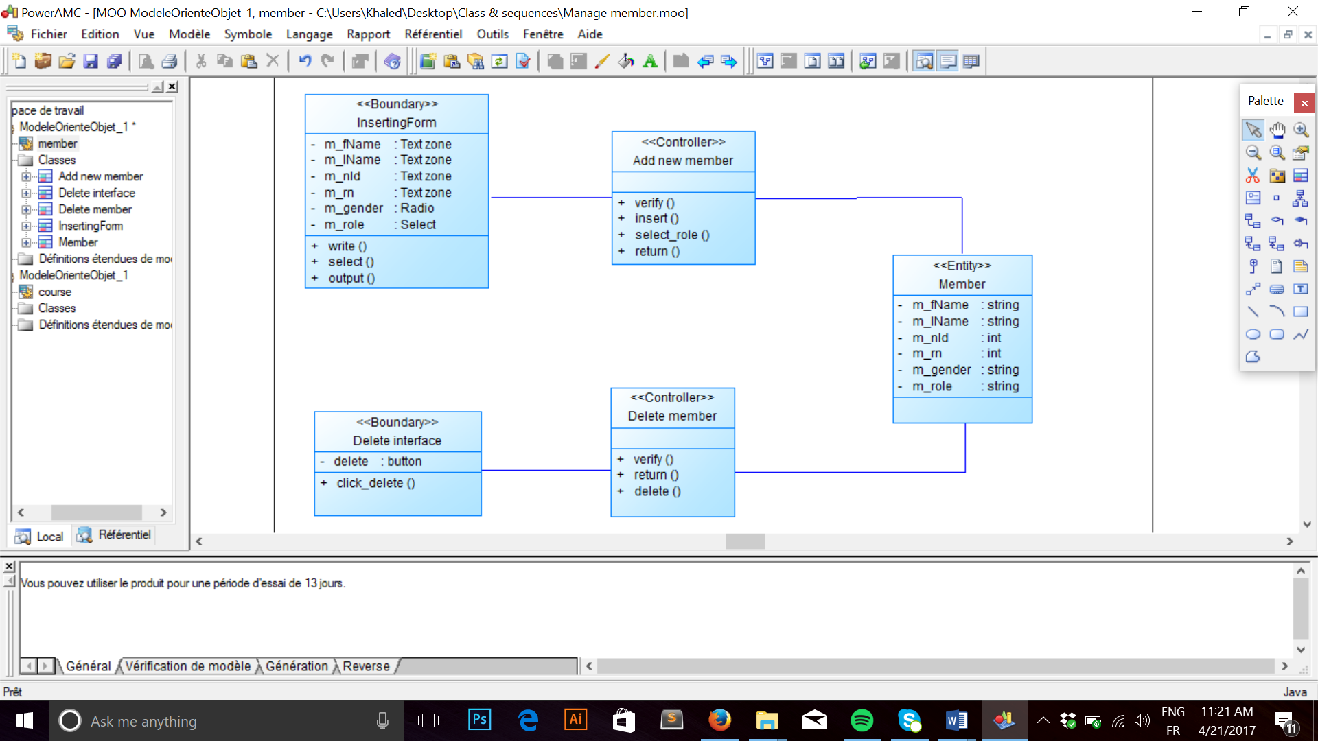

**Figure: Class diagram of the use case *Manage member***

1. **Sequence diagram of the child Add new member**

The following figure presents the sequence diagram of the child *Add new member*



**Figure: Sequence diagram of the child Add new member**

1. **Sequence diagram of the child *Delete member***

The following figure presents the sequence diagram of the child *Delete member*

**

**Figure: Sequence diagram of the child *Delete member***

1. **Analysis of the use case *Manage course***

In order to model the use case “*Manage course”*. in first order, we used a class diagram which presents two interfaces, two controllers and one entity class, to illustrate the interaction between them we will present a detailed sequence diagram.

1. **Class diagram of the use case *Manage course***

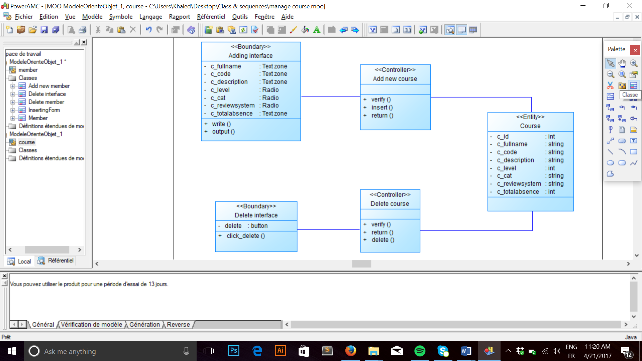The following figure presents the class diagram of the use case *Manage course*

**Figure: Class diagram of the use case *Manage course***

1. **Sequence diagram of the child Add new course**

The following figure presents the sequence diagram of the child *Add new member*



**Figure: Sequence diagram of the child Add new course**

1. **Sequence diagram of the child *Delete course***

The following figure presents the sequence diagram of the child *Delete course*



**Figure: Sequence diagram of the child *Delete course***

1. **Analysis of the use case Consult document**

In order to model the use case “*Consult document”*. in first order, we used a class diagram which presents one interfaces, four controllers and two entity class, to illustrate the interaction between them we will present a detailed sequence diagram.

1. **Class diagram of the use case *Consult document***

The following figure presents the class diagram of the use case *Consult document*

**

**Figure: Class diagram of the use case *Consult document***

1. **Sequence diagram of the child Download lecture note**

The following figure presents the sequence diagram of the child *Download lecture note*



**Figure: Sequence diagram of the child Download lecture note**

1. **Sequence diagram of the child *Download practical work***

The following figure presents the sequence diagram of the child *Download practical work*



**Figure: Sequence diagram of the child *Download practical work***

1. **Sequence diagram of the child Download homework announcement**

The following figure presents the sequence diagram of the child *Download homework announcement*



**Figure: Sequence diagram of the child Download homework announcement**

1. **Sequence diagram of the child *Download project announcement***

The following figure presents the sequence diagram of the child *Download project announcement*

**

**Figure: Sequence diagram of the child *Download project announcement***

1. **Analysis of the use case *Submit document***

In order to model the use case “*Submit document”*. in first order, we used a class diagram which presents one interfaces, two controllers and three entity class, to illustrate the interaction between them we will present a detailed sequence diagram.

1. **Class diagram of the use case *Submit document***

The following figure presents the class diagram of the use case *Submit document*

**

**Figure: Class diagram of the use case *Submit document***

1. **Sequence diagram of the child Submit homework**

The following figure presents the sequence diagram of the child *Submit homework*

**Figure: Sequence diagram of the child Submit homework**

1. **Sequence diagram of the child *Submit project***

The following figure presents the sequence diagram of the child *Submit project*

**

**Figure: Sequence diagram of the child *Submit project***

1. **Analysis of the use case *Upload document***

In order to model the use case *Upload document*. in first order, we used a class diagram which presents one interfaces, four controllers and two entity class, to illustrate the interaction between them we will present a detailed sequence diagram.

1. **Class diagram of the use case *Upload document***

The following figure presents the class diagram of the use case *Upload document*

**

**Figure: Class diagram of the use case *Upload document***

1. **Sequence diagram of the child Upload lecture note**

The following figure presents the sequence diagram of the child *Upload lecture note*



**Figure: Sequence diagram of the child Upload lecture note**

1. **Sequence diagram of the child *Upload practical work***

**The following figure presents the sequence diagram of the child *Upload practical work*

**Figure: Sequence diagram of the child *Upload practical work***

1. **Sequence diagram of the child Upload homework announcement**

The following figure presents the sequence diagram of the child *Upload homework announcement*



**Figure: Sequence diagram of the child Upload homework announcement**

1. **Sequence diagram of the child *Upload project announcement***

The following figure presents the sequence diagram of the child *Upload project announcement*



**Figure: Sequence diagram of the child *Upload project announcement***

1. **Analysis of the use case *Consult submitted document***

In order to model the use case “*Consult submitted document”*. in first order, we used a class diagram which presents one interfaces, four controllers and two entity class, to illustrate the interaction between them we will present a detailed sequence diagram.

1. **Class diagram of the use case *Consult submitted document***

The following figure presents the class diagram of the use case *Consult submitted document*

**

**Figure: Class diagram of the use case *Consult submitted document***

1. **Sequence diagram of the child Check student homework**

The following figure presents the sequence diagram of the child *Check student homework*



**Figure: Sequence diagram of the child Check student homework**

1. **Sequence diagram of the child *Check student project***

The following figure presents the sequence diagram of the child *Check student project*



**Figure: Sequence diagram of the child *Check student project***

1. ***Software architectural pattern***

***The figure x shows*** a diagram of interactions within the MVC pattern.

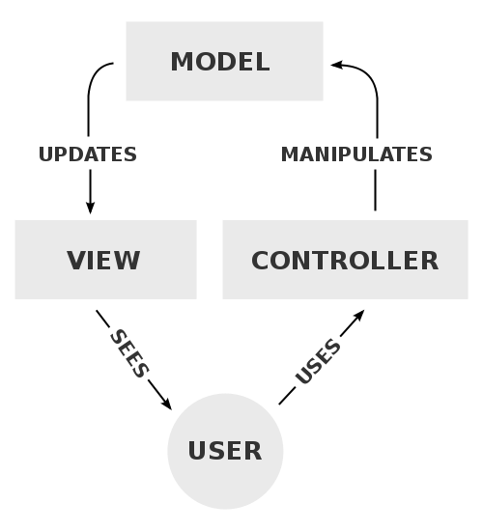

***Figure x:*** Diagram of interactions within the MVC pattern.

**Model–View–Controller** (**MVC**) is a software architectural pattern for implementing user interfaces on computers. It divides a given application into three interconnected parts in order to separate internal representations of information from the ways that information is presented to and accepted from the user. The MVC design pattern decouples these major components allowing for efficient code reuse and parallel development.

1. ***Conclusion***

In the inception phase, we identified the functional and non-functional requirements and we specified the use cases and their priorities, which will facilitate the transition to the elaboration phase.

**CHAPTER 3: ELABORATION PHASE**

1. Introduction
2. Refinement of medium priority use cases
3. Use case diagram of medium priority
4. Technical analysis
5. Conclusion

**CHAPTER 3: ELABORATION PHASE**

1. **Introduction**

The elaboration phase is the second phase of the RUP methodology and it is the title of our third chapter which focus on the refinement and use case diagram of medium priority.

1. **Refinement of medium priority use cases**
2. **Refine the use case *Manage event***

* **The use case diagram**



* **The use case definition of the child *Post new event***

|  |  |
| --- | --- |
| **Use Case Name:** | Post new event |
| **Actor:** | Administrator |
| **Description:** | Administrator could post a new event. |
| **Preconditions:** | Administrator identity has been authenticated |
| **Post conditions:** | Posted event |
| **Priority:** | MEDIUM |
| **Normal Course of Events:** | * The administrator clicks on the “New Event “webpage. * The system displays the adding event registration form. * The administrator completes the form which contains: the event name, the cover picture, the location, the starting date, the ending date and a brief description. * The administrator clicks on the Create button. * The system adds the event in the database and displays a success message. |
| **Exceptions:** | An error message will be displayed if the administrator does not complete all the required fields. |

**Table 29: The use case definition of the child *Post new event***

* **The use case definition of the child *Modify event***

|  |  |
| --- | --- |
| **Use Case Name:** | Modify event |
| **Actor:** | Administrator |
| **Description:** | Administrator could modify an event from the system. |
| **Preconditions:** | Administrator identity has been authenticated |
| **Post conditions:** | Modified event |
| **Priority:** | MEDIUM |
| **Normal Course of Events:** | * The administrator clicks on the “Events” webpage. * The system displays the list of all events. * The administrator clicks on the Edit button to change the event information and clicks on the Update button. * The system update the event information in the database and displays a success message. |
| **Exceptions:** | An error message will be displayed if the administrator does not complete all the required fields. |

**Table 30: The use case definition of the child *Modify event***

* **The use case definition of the child *Delete event***

|  |  |
| --- | --- |
| **Use Case Name:** | Delete event |
| **Actor:** | Administrator |
| **Description:** | Administrator could delete an event from the system. |
| **Preconditions:** | Administrator identity has been authenticated |
| **Post conditions:** | Deleted event |
| **Priority:** | MEDIUM |
| **Normal Course of Events:** | * The administrator clicks on “Events” webpage. * The system displays the list of all events. * The administrator clicks on the Delete button. * The system delete the event from the database and displays a success message. |

**Table 31: The use case definition of the child *Delete event***

1. **Refine the use case *Check attendance letter request***

* **The use case diagram**



* **The use case definition of the child *Accept attendance letter request***

|  |  |
| --- | --- |
| **Use Case Name:** | Accept attendance letter request |
| **Actor:** | Administrator |
| **Description:** | Administrator could accept the attendance letter request. |
| **Preconditions:** | Administrator identity has been authenticated |
| **Post conditions:** | Accepted attendance letter request |
| **Priority:** | MEDIUM |
| **Normal Course of Events:** | * The administrator clicks on the “Attendance letter” webpage. * The system displays a list of all suggestion of the student for the attendance letter. * The administrator clicks on the Accept button. * The system display the Print button which the administrator can print the attendance letter. |

**Table 32: The use case definition of the child *Accept attendance letter request***

* **The use case definition of the child *Reject attendance letter request***

|  |  |
| --- | --- |
| **Use Case Name:** | Reject attendance letter request |
| **Actor:** | Administrator |
| **Description:** | Administrator could reject the attendance letter request. |
| **Preconditions:** | Administrator identity has been authenticated |
| **Post conditions:** | Rejected attendance letter request. |
| **Priority:** | MEDIUM |
| **Normal Course of Events:** | * The administrator clicks on the “Attendance letter” webpage. * The system displays a list of all suggestion of the student for the attendance letter. * The administrator clicks on the Reject button. * The system delete the request from the administrator list. |

**Table 33: The use case definition of the child *Reject attendance letter request***

1. **Refine the use case *Check student event request***

* **The use case diagram**

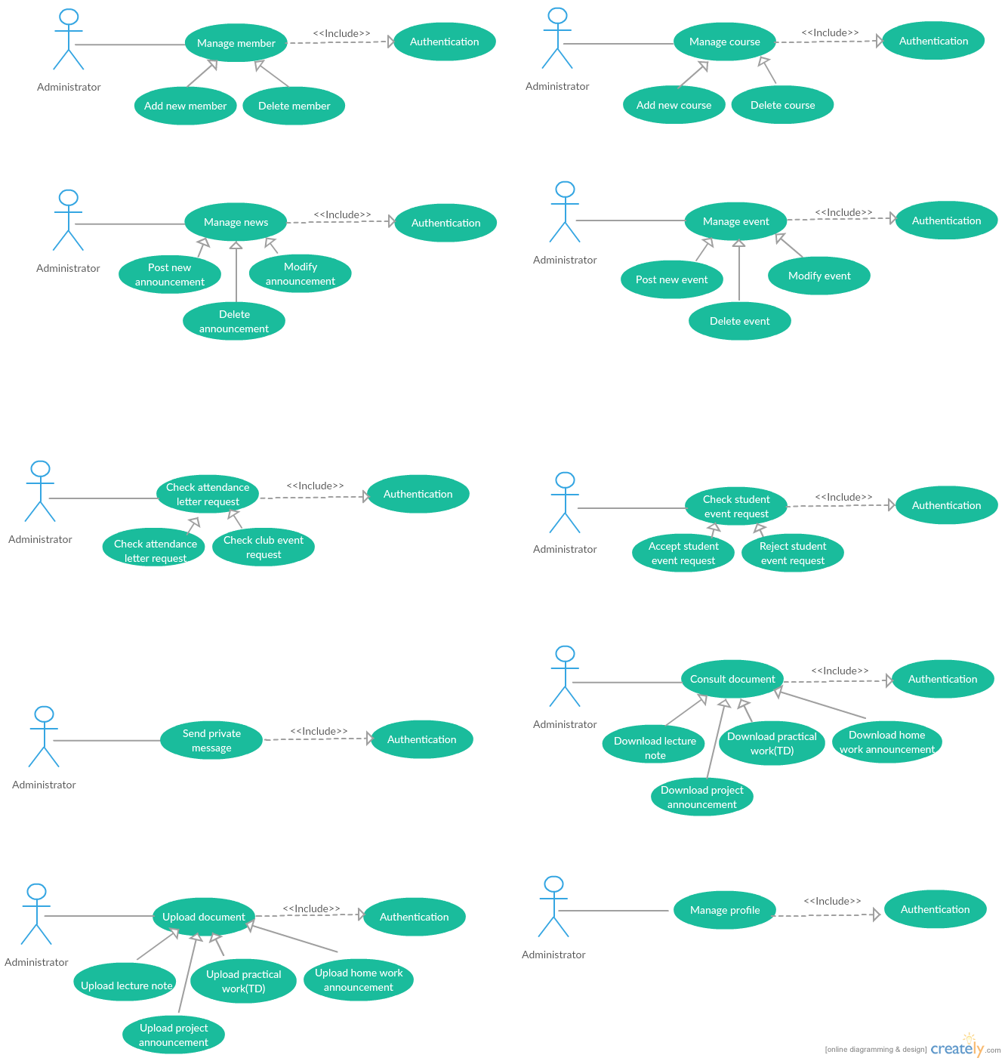

* **The use case definition of the child *Accept student event request***

|  |  |
| --- | --- |
| **Use Case Name:** | Accept student event request |
| **Actor:** | Administrator |
| **Description:** | Administrator could accept the request of the student for the event. |
| **Preconditions:** | Administrator identity has been authenticated |
| **Post conditions:** | Accepted student event request |
| **Priority:** | MEDIUM |
| **Normal Course of Events:** | * The administrator clicks on the “Events” webpage. * The system displays a list of all suggestion of the student for the event. * The administrator clicks on the Accept button. * The system notifies the publisher and display the event for all the members. |

**Table 34: The use case definition of the child *Accept student event request***

* **The use case definition of the child *Reject student event request***

|  |  |
| --- | --- |
| **Use Case Name:** | Reject student event request |
| **Actor:** | Administrator |
| **Description:** | Administrator could reject the request of the student for the event. |
| **Preconditions:** | Administrator identity has been authenticated |
| **Post conditions:** | Rejected student event request. |
| **Priority:** | MEDIUM |
| **Normal Course of Events:** | * The administrator clicks on the “Events” webpage. * The system displays a list of all suggestion of the student for the event. * The administrator clicks on the Reject button. * The system notifies the publisher and delete the event. |

**Table 35: The use case definition of the child *Reject student event request***

1. **Refine the use case *Send private message***

* **The use case diagram**



* **The use case definition of Send private message**

|  |  |
| --- | --- |
| **Use Case Name:** | Send private message |
| **Actor:** | Administrator |
| **Description:** | Administrator could send the private message |
| **Preconditions:** | Administrator identity has been authenticated. |
| **Post conditions:** | Sent message. |
| **Priority:** | MEDIUM |
| **Normal Course of Events:** | * The administrator clicks on the “Message” webpage. * The system displays the adding new message form. * The administrator clicks on the New message button * The system displays an empty message. * The administrator completes the form which contains: the receiver name, the message and the attached file. * The administrator clicks on the Send button. * The system save the message in the database and displays a success message. |
| **Alternative Courses:** | * The administrator can cancel sending the message. |
| **Exception:** | An error message will be displayed if the administrator does not complete all the required fields. |

**Table 36: The use case definition of Send private message**

1. **Refine the use case *Manage discussion forum***

* **The use case diagram**



* **The use case definition of the child *Post new discussion topic***

|  |  |
| --- | --- |
| **Use Case Name:** | Post new discussion topic |
| **Actor:** | Student |
| **Description:** | Student could post a new discussion topic |
| **Preconditions:** | Student identity has been authenticated. |
| **Post conditions:** | Posted discussion topic |
| **Priority:** | MEDIUM |
| **Normal Course of Events:** | * The student clicks on the name of the course. * The system displays the course webpage. * The student clicks on the Discussion topic webpage. * The system displays all the existing discussion topic in the course. * The student clicks on the Add new topic button. * The system display the adding discussion topic form. * The student completes the form which contains: the title and the description. * The student clicks on the Post button. * The system adds the discussion topic in the database and displays a success message. |
| **Exception:** | An error message will be displayed if the student does not complete all the required fields. |

**Table 37: The use case definition of the child *Post new discussion topic***

* **The use case definition of the child *Delete discussion topic***

|  |  |
| --- | --- |
| **Use Case Name:** | Delete discussion topic |
| **Actor:** | Student |
| **Description:** | Student could delete the discussion topic |
| **Preconditions:** | Student identity has been authenticated. |
| **Post conditions:** | Deleted discussion topic |
| **Priority:** | MEDIUM |
| **Normal Course of Events:** | * The student clicks on the name of the course. * The system displays the course webpage. * The student clicks on the Discussion topic webpage. * The system displays all the existing discussion topic in the course. * The student clicks on the Delete button. * The system deletes the discussion topic from the database and displays a success message. |

**Table 38: The use case definition of the child *Delete discussion topic***

* **The use case definition of the child *Comment discussion topic***

|  |  |
| --- | --- |
| **Use Case Name:** | Comment discussion topic |
| **Actor:** | Student |
| **Description:** | Student could comment the discussion topic |
| **Preconditions:** | Student identity has been authenticated. |
| **Post conditions:** | Commented discussion topic |
| **Priority:** | MEDIUM |
| **Normal Course of Events:** | * The student clicks on the name of the course. * The system displays the course webpage. * The student clicks on the Discussion topic webpage. * The system displays all the existing discussion topic in the course. * The student clicks on the Comment button located in the addressed topic. * The system display a text area which contains the student comment. * The student clicks on the Post button. * The system adds the comment in the database and displays a success message. |
| **Exception:** | The student cannot add a comment as a file. |

**Table 39: The use case definition of the child *Comment discussion topic***

1. **Refine the use case *Check news***

* **The use case diagram**



* **The use case definition of the child *Check administrative announcement***

|  |  |
| --- | --- |
| **Use Case Name:** | Check administrative announcement |
| **Actor:** | Student |
| **Description:** | Student could check the administrative announcement |
| **Preconditions:** | Student identity has been authenticated. |
| **Post conditions:** | Checked administrative announcement |
| **Priority:** | MEDIUM |
| **Normal Course of Events:** | * The student clicks on the “News” webpage. * The system displays the list of all news addressed to a specific level and/or category. |

**Table 40: The use case definition of the child *Check administrative announcement***

* **The use case definition of the child *Check event***

|  |  |
| --- | --- |
| **Use Case Name:** | Check event |
| **Actor:** | Student |
| **Description:** | Student could check the event |
| **Preconditions:** | Student identity has been authenticated. |
| **Post conditions:** | Checked event |
| **Priority:** | MEDIUM |
| **Normal Course of Events:** | * The student clicks on the “Events” webpage. * The system displays the list of all the events published by the administrator or by the students. |

**Table 41: The use case definition of the child *Check event***

1. **Refine the use case *Manage event***

* **The use case diagram**



* **The use case definition of the child *Request new event***

|  |  |
| --- | --- |
| **Use Case Name:** | Request new event |
| **Actor:** | Student |
| **Description:** | Student could request a new event. |
| **Preconditions:** | Student identity has been authenticated |
| **Post conditions:** | Requested event |
| **Priority:** | MEDIUM |
| **Normal Course of Events:** | * The student clicks on the New Event webpage. * The system displays the adding new event form. * The student completes the form which contains: the event name, the cover picture, the location, the starting date, the ending date, a brief description, the club name, the club picture and the supervisor name. * The student clicks on the Create button. * The system send the request to the administrator and to the supervisor. * The system adds the event in the database and displays a success message. |
| **Exceptions:** | An error message will be displayed if the student does not complete all the required fields. |

**Table 42: The use case definition of the child *Request new event***

* **The use case definition of the child *Modify event***

|  |  |
| --- | --- |
| **Use Case Name:** | Modify event |
| **Actor:** | Student |
| **Description:** | Student could modify the event. |
| **Preconditions:** | Student identity has been authenticated |
| **Post conditions:** | Modified event |
| **Priority:** | MEDIUM |
| **Normal Course of Events:** | * The student clicks on the Events webpage. * The system displays the list of the events. * The student clicks on the Edit button to change the event information and clicks on the Update button. * The system update the event information in the database and displays a success message. |
| **Exceptions:** | An error message will be displayed if the student does not complete the required fields. |

**Table 43: The use case definition of the child *Modify event***

* **The use case definition of the child *Delete event***

|  |  |
| --- | --- |
| **Use Case Name:** | Delete event |
| **Actor:** | Student |
| **Description:** | Student could delete the event. |
| **Preconditions:** | Student identity has been authenticated |
| **Post conditions:** | Deleted event |
| **Priority:** | MEDIUM |
| **Normal Course of Events:** | * The student clicks on the Events webpage. * The system displays the list of the events. * The student clicks on the Delete button. He could delete all the events. * The system delete the event from the database and displays a success message. |

**Table 44: The use case definition of the child *Delete event***

1. **Refine the use case *Request attendance letter***

* **The use case diagram**
* **The use case definition of Request attendance letter**

|  |  |
| --- | --- |
| **Use Case Name:** | Request attendance letter |
| **Actor:** | Student |
| **Description:** | Student could request the attendance letter |
| **Preconditions:** | Student identity has been authenticated |
| **Post conditions:** | Requested attendance letter |
| **Priority:** | MEDIUM |
| **Normal Course of Events:** | * The student clicks on the “Attendance letter” webpage. * The system displays the adding attendance letter request form. * The student need to add two instructors of the courses. * The system notifies the administrator and the instructors. * In the case that they accept, print button appear to the administrator. |
| **Exceptions:** | An error message will be displayed if the student does not complete all the required fields. |

**Table 45: The use case definition of the child *Check grades***

1. **Refine the use case *Manage discussion forum***

* **The use case diagram**



* **The use case definition of the child *Post new discussion topic***

**Table 46: The use case definition of the child *Post new discussion topic***

|  |  |
| --- | --- |
| **Use Case Name:** | Post new discussion topic |
| **Actor:** | Instructor |
| **Description:** | Instructor could post a new discussion topic |
| **Preconditions:** | Instructor identity has been authenticated. |
| **Post conditions:** | Posted discussion topic |
| **Priority:** | MEDIUM |
| **Normal Course of Events:** | * The instructor clicks on the name of the course. * The system displays the course webpage. * The instructor clicks on the Discussion topic webpage. * The system displays all the existing discussion topic in the course. * The instructor clicks on the Add new topic button. * The system display the adding discussion topic form. * The instructor student completes the form which contains: the title and the description. * The instructor clicks on the Post button. * The system adds the discussion topic in the database and displays a success message. |
| **Exception:** | An error message will be displayed if the instructor does not complete all the required fields. |

* **The use case definition of the child *Delete discussion topic***

|  |  |
| --- | --- |
| **Use Case Name:** | Delete discussion topic |
| **Actor:** | Instructor |
| **Description:** | Instructor could delete the discussion topic |
| **Preconditions:** | Instructor identity has been authenticated. |
| **Post conditions:** | Deleted discussion topic |
| **Priority:** | MEDIUM |
| **Normal Course of Events:** | * The instructor clicks on the name of the course. * The system displays the course webpage. * The instructor clicks on the Discussion topic webpage. * The system displays all the existing discussion topic in the course. * The instructor clicks on the Delete button. * The system deletes the discussion topic from the database and displays a success message. |

**Table 47: The use case definition of the child *Delete discussion topic***

* **The use case definition of the child *Comment discussion topic***

|  |  |
| --- | --- |
| **Use Case Name:** | Comment discussion topic |
| **Actor:** | Instructor |
| **Description:** | Instructor could comment the discussion topic |
| **Preconditions:** | Instructor identity has been authenticated. |
| **Post conditions:** | Commented discussion topic |
| **Priority:** | MEDIUM |
| **Normal Course of Events:** | * The instructor clicks on the name of the course. * The system displays the course webpage. * The instructor clicks on the Discussion topic webpage. * The system displays all the existing discussion topic in the course. * The instructor clicks on the Comment button located in the addressed topic. * The system display a text area which contains the instructor comment. * The instructor clicks on the Post button. * The system adds the comment in the database and displays a success message. |
| **Exception:** | The instructor cannot add a comment as a file. |

**Table 48: The use case definition of the child *Comment discussion topic***

1. **Refine the use case *Check news***

* **The use case diagram**



* **The use case definition of the child *Check administrative announcement***

|  |  |
| --- | --- |
| **Use Case Name:** | Check administrative announcement |
| **Actor:** | Instructor |
| **Description:** | Instructor could check the administrative announcement |
| **Preconditions:** | Instructor identity has been authenticated. |
| **Post conditions:** | Checked administrative announcement |
| **Priority:** | MEDIUM |
| **Normal Course of Events:** | * The instructor clicks on the “News” webpage. * The system displays the list of all news addressed to a specific level and/or category. |

**Table 49: The use case definition of the child *Check administrative announcement***

* **The use case definition of the child *Check event***

|  |  |
| --- | --- |
| **Use Case Name:** | Check event |
| **Actor:** | Instructor |
| **Description:** | Instructor could check the event |
| **Preconditions:** | Instructor identity has been authenticated. |
| **Post conditions:** | Checked event |
| **Priority:** | MEDIUM |
| **Normal Course of Events:** | * The instructor clicks on the “Events” webpage. * The system displays the list of all the events published by the administrator or by the students. |

**Table 50: The use case definition of the child *Check event***

1. **Refine the use case *Check attendance letter request as supervisor***

* **The use case diagram**
* **The use case definition of the child *Accept attendance letter request***

|  |  |
| --- | --- |
| **Use Case Name:** | Accept attendance letter request |
| **Actor:** | Instructor |
| **Description:** | Instructor could accept the attendance letter request. |
| **Preconditions:** | Instructor identity has been authenticated |
| **Post conditions:** | Accepted attendance letter request. |
| **Priority:** | MEDIUM |
| **Normal Course of Events:** | * The instructor clicks on the “Attendance letter “webpage. * The system displays suggestion of the student for the attendance letter as supervisor. * The Instructor clicks on the Accept button. * The system delete the request from the instructor Attendance letter webpage. * The system notifies the administrator and the student. |

**Table 51: The use case definition of the child *Accept attendance letter request***

* **The use case definition of the child *Reject attendance letter request***

**Table 52: The use case definition of the child *Reject attendance letter request***

|  |  |
| --- | --- |
| **Use Case Name:** | Reject attendance letter request |
| **Actor:** | Instructor |
| **Description:** | Instructor could reject the attendance letter request. |
| **Preconditions:** | Instructor identity has been authenticated |
| **Post conditions:** | Rejected attendance letter request. |
| **Priority:** | MEDIUM |
| **Normal Course of Events:** | * The instructor clicks on the “Attendance letter” webpage. * The system displays a list of all suggestion of the student for the attendance letter as supervisor. * The instructor clicks on the Reject button. * The system delete the request from the instructor webpage. * The system notifies the student and the administrator. |

1. **Refine the use case *Check student event request as supervisor***

* **The use case diagram**



* **The use case definition of the child *Accept student event request***

|  |  |
| --- | --- |
| **Use Case Name:** | Accept student event request |
| **Actor:** | Instructor |
| **Description:** | Instructor could accept the request of the student for the event. |
| **Preconditions:** | Instructor identity has been authenticated |
| **Post conditions:** | Accepted student event request. |
| **Priority:** | MEDIUM |
| **Normal Course of Events:** | * The instructor clicks on the “Events” webpage. * The system displays a list of all suggestion of the student for the event as supervisor. * The instructor clicks on the Accept button. * The system deletes the event suggestion from the instructor Events webpage. * The system notifies the publisher and the administrator. |

**Table 53: The use case definition of the child *Accept student event request***

* **The use case definition of the child *Reject student event request***

|  |  |
| --- | --- |
| **Use Case Name:** | Reject student event request |
| **Actor:** | Instructor |
| **Description:** | Instructor could reject the request of the student for the event. |
| **Preconditions:** | Instructor identity has been authenticated |
| **Post conditions:** | Rejected student event request. |
| **Priority:** | MEDIUM |
| **Normal Course of Events:** | * The instructor clicks on the “Events” webpage. * The system displays a list of all suggestion of the student for the event. * The instructor clicks on the Reject button. * The system deletes the event suggestion from the instructor Events webpage. * The system notifies the publisher and the administrator. |

**Table 54: The use case definition of the child *Reject student event request***

1. **Use case diagram of medium priority**

The figure below shows the use case diagram after refinement of medium priority use cases.

**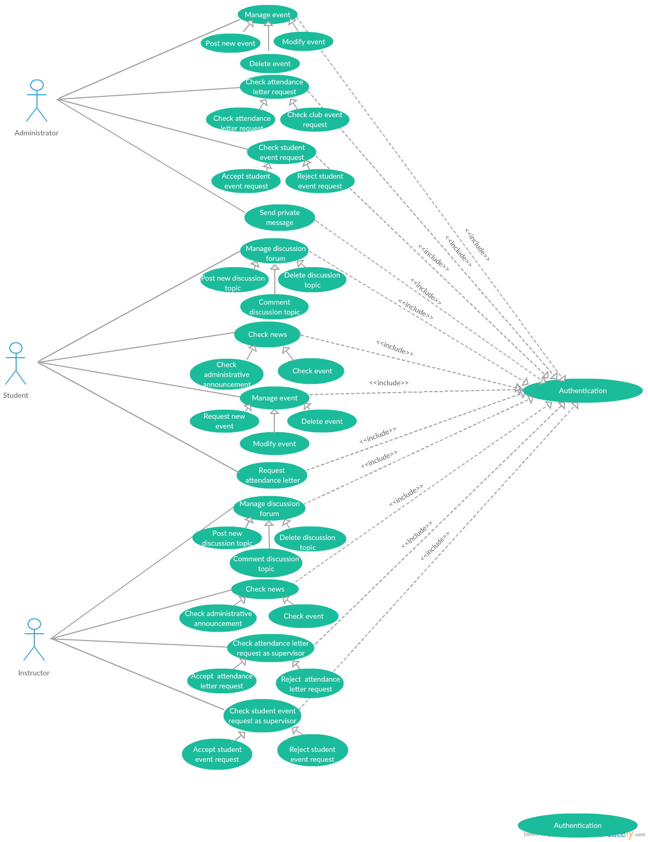*Figure: Use cases diagram of medium priority after refinement***

1. **Technical analysis**

After refining use cases of medium priority, we will move on to technical analysis.

In the following we will present the class and sequences diagrams associated to each use case and model their interfaces and their controllers.

1. **Analysis of the use case *Manage event***

In order to model the use case “*Manage event”*. in first order, we used a class diagram which presents three interfaces, three controllers and one entity class, to illustrate the interaction between them we will present a detailed sequence diagram.

1. **Class diagram of the use case *Manage event***

The following figure presents the class diagram of the use case *Manage event*

**

**Figure: Class diagram of the use case *Manage event***

1. **Sequence diagram of the child Post new event**

The following figure presents the sequence diagram of the child *Post new event*



**Figure: Sequence diagram of the child Post new event**

1. **Sequence diagram of the child *Modify event***

****The following figure presents the sequence diagram of the child *Modify event*

**Figure: Sequence diagram of the child *Modify event***

1. **Sequence diagram of the child *Delete event***

The following figure presents the sequence diagram of the child *Delete event*



**Figure: Sequence diagram of the child *Delete event***

1. **Analysis of the use case *Check Attendance letter request***

In order to model the use case “*Attendance letter request”*. in first order, we used a class diagram which presents one interfaces, two controllers and one entity class, to illustrate the interaction between them we will present a detailed sequence diagram.

1. **Class diagram of the use case *Check Attendance letter request***

The following figure presents the class diagram of the use case *Check Attendance letter request*

**

**Figure: Class diagram of the use case *Check Attendance letter request***

1. **Sequence diagram of the child Accept attendance letter request**

The following figure presents the sequence diagram of the child *Accept attendance letter request*



**Figure: Sequence diagram of the child *Accept attendance letter request***

1. **Sequence diagram of the child *Reject attendance letter request***

The following figure presents the sequence diagram of the child *Reject attendance letter request*



**Figure: Sequence diagram of the child *Reject attendance letter request***

1. **Analysis of the use case *Manage discussion forum***

In order to model the use case “*Manage discussion forum”*. in first order, we used a class diagram which presents three interfaces, three controllers and four entity class, to illustrate the interaction between them we will present a detailed sequence diagram.

1. **Class diagram of the use case *Manage discussion forum***

The following figure presents the class diagram of the use case *Manage discussion forum*

**

**Figure: Class diagram of the use case *Manage discussion forum***

1. **Sequence diagram of the child Post new discussion topic**

The following figure presents the sequence diagram of the child *Post new discussion topic*

**Figure: Sequence diagram of the child Post new discussion topic**

1. **Sequence diagram of the child *Delete discussion topic***

The following figure presents the sequence diagram of the child *Delete discussion topic*



**Figure: Sequence diagram of the child *Delete discussion topic***

1. **Sequence diagram of the child Comment discussion topic**

The following figure presents the sequence diagram of the child *Comment discussion topic*



**Figure: Sequence diagram of the child Comment discussion topic**

1. **Analysis of the use case *Request attendance letter***

In order to model the use case “*Request attendance letter”*. in first order, we used a class diagram which presents one interfaces, one controllers and two entity class, to illustrate the interaction between them we will present a detailed sequence diagram.

1. **Class diagram of the use case *Request attendance letter***

The following figure presents the class diagram of the use case *Request attendance letter*

**

**Figure: Class diagram of the use case *Request attendance letter***

1. **Sequence diagram of the use case *Request attendance letter***

The following figure presents the sequence diagram of the use case *Request attendance letter*



**Figure: Sequence diagram of the use case *Request attendance letter***

1. **Conclusion**

In the elaboration chapter, we have done the refinement and use case diagram of medium priority. This phase allows us to start the next chapter that is interested in use cases of low priority.

**CHAPTER 4: CONSTRUCTION PHASE**

1. Introduction
2. Refinement of low priority use cases
3. Use case diagram of low priority
4. Technical analysis
5. Graphical analysis
6. Conclusion

**CHAPTER 4: CONSTRUCTION PHASE**

1. **Introduction**

In this chapter, in the first part, we will analyses the general use cases of the communication tools to faculty members and students. In the second part, we will describe the model scenario and the prototype of user interfaces

1. **Refinement of low priority use cases**
2. **Refine the use case *Consult document***

* 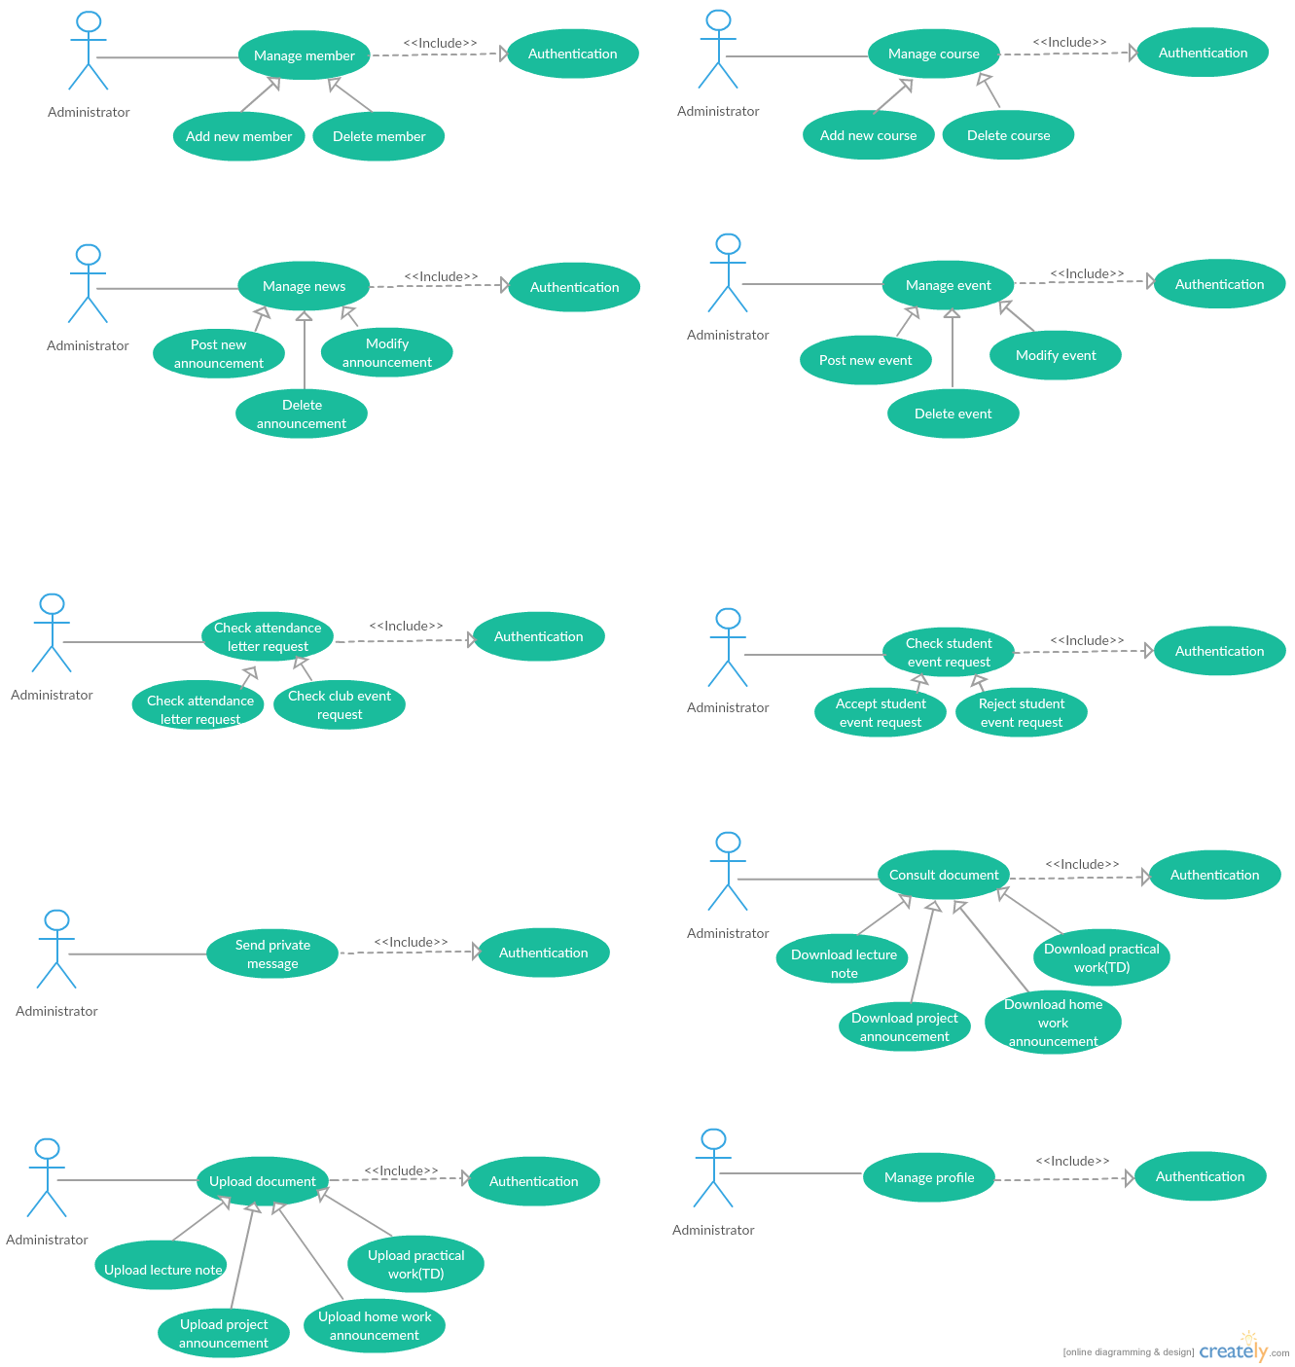**The use case diagram**
* **The use case definition of the child *Download lecture note***

|  |  |
| --- | --- |
| **Use Case Name:** | Download lecture note |
| **Actor:** | Administrator |
| **Description:** | Administrator could download lecture notes. |
| **Preconditions:** | Administrator identity has been authenticated. |
| **Post conditions:** | Downloaded lecture note |
| **Priority:** | LOW |
| **Normal Course of Events:** | * The administrator clicks on the name of the course. * The system displays course webpage. * The administrator clicks on the Lecture notes webpage. * The system displays all the existing lecture notes related to the course. * The administrator clicks on the download icon next to the lecture note row. |

**Table 55: The use case definition of the child *Download lecture note***

* **The use case definition of the child *Download practical work (TD)***

|  |  |
| --- | --- |
| **Use Case Name:** | Download practical work (TD) |
| **Actor:** | Administrator |
| **Description:** | Administrator could download practical work. |
| **Preconditions:** | Administrator identity has been authenticated. |
| **Post conditions:** | Downloaded practical work |
| **Priority:** | LOW |
| **Normal Course of Events:** | * The administrator clicks on the name of the course. * The system displays the course webpage. * The administrator clicks on the Lecture notes webpage. * The system displays all the existing lecture notes related to the course * The administrator clicks on the name of the lecture note. * The system displays the list of all the practical work related to a specific lecture note. * The administrator clicks on the name of the addressed practical work. |

**Table 56: The use case definition of the child *Download practical work (TD)***

* **The use case definition of the child *Download homework announcement***

|  |  |
| --- | --- |
| **Use Case Name:** | Download homework announcement |
| **Actor:** | Administrator |
| **Description:** | Administrator could download homework announcement. |
| **Preconditions:** | Administrator identity has been authenticated. |
| **Post conditions:** | Downloaded homework announcement |
| **Priority:** | LOW |
| **Normal Course of Events:** | * The administrator clicks on the name of the course. * The system displays the course webpage. * The administrator clicks on the Homework webpage. * The system displays all the existing home works related to the course. * The administrator clicks on the download icon in next to the homework announcement row. |

**Table 57: The use case definition of the child *Download homework announcement***

* **The use case definition of the child *Download project announcement***

|  |  |
| --- | --- |
| **Use Case Name:** | Download project announcement |
| **Actor:** | Administrator |
| **Description:** | Administrator could download project announcement. |
| **Preconditions:** | Administrator identity has been authenticated. |
| **Post conditions:** | Downloaded project announcement |
| **Priority:** | LOW |
| **Normal Course of Events:** | * The administrator clicks on the name of the course. * The system displays the course webpage. * The administrator clicks on the project webpage. * The system displays all the existing projects related to the course. * The administrator clicks on the download icon located next to the project announcement row. |

**Table 58: The use case definition of the child *Download project announcement***

1. **Refine the use case *Upload document***

* **The use case diagram**



* **The use case definition of the child *Upload lecture note***

|  |  |
| --- | --- |
| **Use Case Name:** | Upload lecture note |
| **Actor:** | Administrator |
| **Description:** | Administrator could upload the lecture note. |
| **Preconditions:** | Administrator identity has been authenticated. |
| **Post conditions:** | Uploaded lecture note. |
| **Priority:** | LOW |
| **Normal Course of Events:** | * The administrator clicks on the name of the course. * The system displays the course webpage. * The administrator clicks on the New Document webpage. * The administrator completes a form which contains: the document type (Lecture Note), the title, the content and an optional description. * The administrator clicks on the Submit button. * The system adds the lecture note in the database and displays a success message. |
| **Alternative Courses:** | * The administrator can modify the existing lecture notes. * The administrator can delete the existing lecture notes. |
| **Exceptions:** | An error message will be displayed if the administrator does not complete all the required fields. |

**Table 59: The use case definition of the child *Upload lecture note***

* **The use case definition of the child *Upload practical work (TD)***

|  |  |
| --- | --- |
| **Use Case Name:** | Upload practical work (TD) |
| **Actor:** | Administrator |
| **Description:** | Administrator could upload the practical work |
| **Preconditions:** | Administrator identity has been authenticated. |
| **Post conditions:** | Uploaded practical work. |
| **Priority:** | LOW |
| **Normal Course of Events:** | * The administrator clicks on the name of the course. * The system displays the course webpage. * The administrator clicks on the Lecture note webpage. * The administrator completes a form which contains an upload zone for the file and an input for the title. * The administrator clicks on the Post button. * The system adds the practical work in the database and displays a success message. |
| **Alternative Courses:** | * The administrator can delete the existing practical work. |
| **Exceptions:** | An error message will be displayed if the administrator does not complete all the required fields. |

**Table 59: The use case definition of the child *Upload practical work (TD)***

* **The use case definition of the child *Upload homework announcement***

|  |  |
| --- | --- |
| **Use Case Name:** | Upload homework announcement |
| **Actor:** | Administrator |
| **Description:** | Administrator could upload the homework announcement. |
| **Preconditions:** | Administrator identity has been authenticated. |
| **Post conditions:** | Uploaded homework announcement. |
| **Priority:** | LOW |
| **Normal Course of Events:** | * The administrator clicks on the name of the course. * The system displays the course webpage. * The administrator clicks on the New Document webpage. * The administrator completes a form which contains: the document type (Homework announcement), the title, the content, an optional description and the due date. * The administrator clicks on the Submit button. * The system adds the homework announcement in the database and displays a success message. |
| **Alternative Courses:** | * The administrator can modify the existing home works. * The administrator can delete the existing home works. |
| **Exceptions:** | An error message will be displayed if the administrator does not complete all the required fields. |

**Table 60: The use case definition of the child *Upload homework announcement***

* **The use case definition of the child *Upload project announcement***

|  |  |
| --- | --- |
| **Use Case Name:** | Upload project announcement |
| **Actor:** | Administrator |
| **Description:** | Administrator could upload the project announcement. |
| **Preconditions:** | Administrator identity has been authenticated. |
| **Post conditions:** | Uploaded project announcement. |
| **Priority:** | LOW |
| **Normal Course of Events:** | * The administrator clicks on the name of the course. * The system displays the course webpage. * The administrator clicks on the New Document webpage. * The administrator completes a form which contains: the document type (Project announcement), the title, the content, an optional description and the due date. * The administrator clicks on the Submit button. * The system adds the project announcement in the database and displays a success message. |
| **Alternative Courses:** | * The administrator can modify the existing projects. * The administrator can delete the existing projects. |
| **Exceptions:** | An error message will be displayed if the administrator does not complete all the required fields. |

**Table 61: The use case definition of the child *Upload project announcement***

1. **Refine the use case *Update profile***

* **The use case diagram**

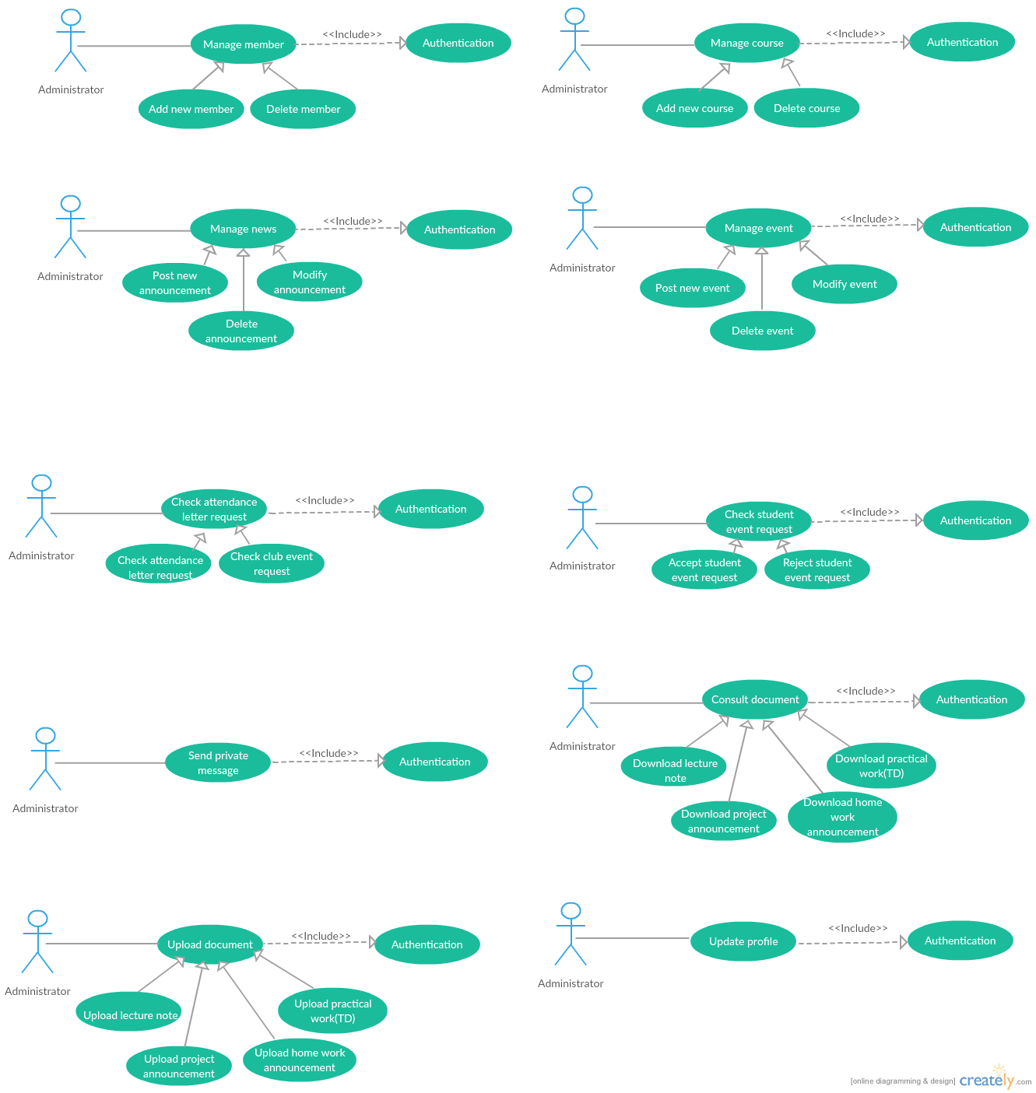

* **The use case definition of Update profile**

|  |  |
| --- | --- |
| **Use Case Name:** | Update profile |
| **Actor:** | Administrator |
| **Description:** | Administrator could update the profile information |
| **Preconditions:** | Administrator identity has been authenticated. |
| **Post conditions:** | Updated profile. |
| **Priority:** | LOW |
| **Normal Course of Events:** | * The administrator clicks on the Profile webpage. * The system displays the personal information. * The administrator clicks on the Edit button. * The administrator could change the profile picture, the mobile phone number, the email address, the skype pseudo, the birth date and the password. * The administrator clicks on the Update button. * The system update the administrator personal information in the database and displays a success message. |
| **Alternative Courses:** | * The administrator can cancel the update. |

**Table 62: The use case definition of Update profile**

1. **Refine the use case *Update profile***

* 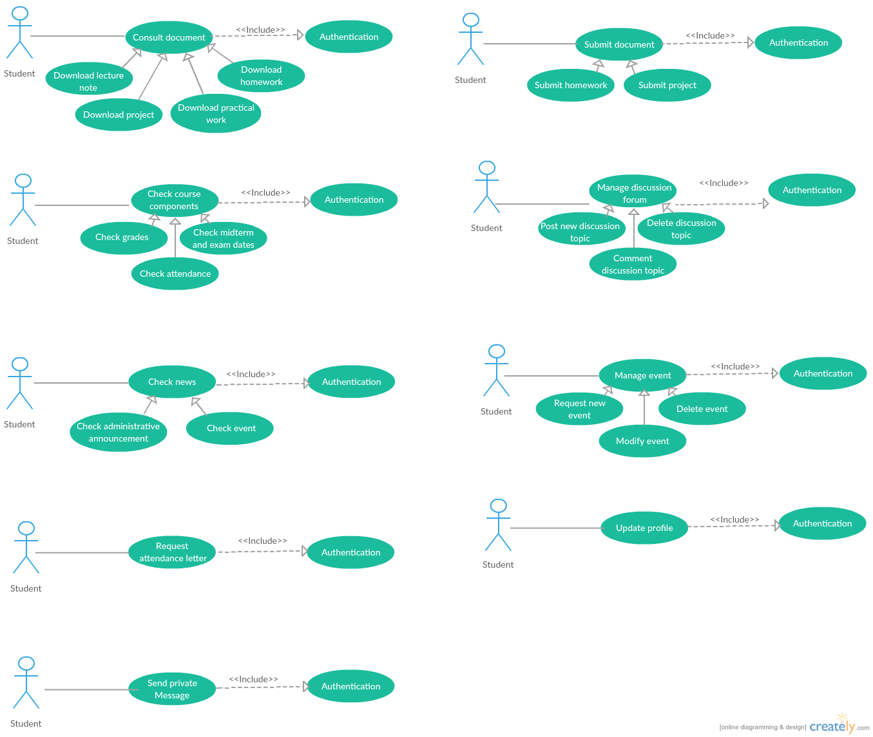**The use case diagram**

* **The use case definition of Update profile**

|  |  |
| --- | --- |
| **Use Case Name:** | Update profile |
| **Actor:** | Student |
| **Description:** | Student could update the profile information |
| **Preconditions:** | Student identity has been authenticated. |
| **Post conditions:** | Updated profile. |
| **Priority:** | LOW |
| **Normal Course of Events:** | * The student clicks on the Profile webpage. * The system displays the personal information. * The student clicks on the Edit button. * The student could change the profile picture, the mobile phone number, the email address, the skype pseudo, the birth date and the password. * The student clicks on the Update button. * The system update the administrator personal information in the database and displays a success message. |
| **Alternative Courses:** | * The student can cancel the update. |

**Table 63: The use case definition of Update profile**

1. **Refine the use case *Send private message***

* **The use case diagram**



* **The use case definition of Send private message**

|  |  |
| --- | --- |
| **Use Case Name:** | Sen private message |
| **Actor:** | Student |
| **Description:** | Student could send the private message |
| **Preconditions:** | Student identity has been authenticated. |
| **Post conditions:** | Sent message. |
| **Priority:** | LOW |
| **Normal Course of Events:** | * The student clicks on the “Message” webpage. * The system displays the adding new message form. * The student clicks on the New message button * The system displays an empty message. * The student completes the form which contains: the receiver name, the message and the attached file. * The student clicks on the Send button. * The system save the message in the database and displays a success message. |
| **Alternative Courses:** | * The student can cancel sending the message. |
| **Exception:** | An error message will be displayed if the student does not complete all the required fields. |

**Table 64: The use case definition of Send private message**

1. **Refine the use case *Update profile***

* **The use case diagram**

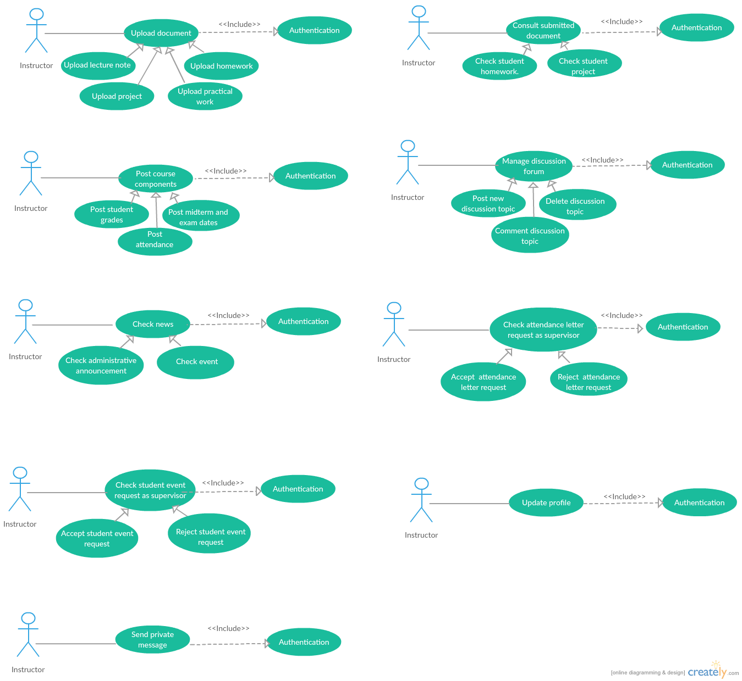

* **The use case definition of Update profile**

|  |  |
| --- | --- |
| **Use Case Name:** | Update profile |
| **Actor:** | Instructor |
| **Description:** | Instructor could update the profile information |
| **Preconditions:** | Instructor identity has been authenticated. |
| **Post conditions:** | Updated profile. |
| **Priority:** | LOW |
| **Normal Course of Events:** | * The instructor clicks on the Profile webpage. * The system displays the personal information. * The instructor clicks on the Edit button. * The instructor could change the profile picture, the mobile phone number, the email address, the skype pseudo, the birth date and the password. * The instructor clicks on the Update button. * The system update the administrator personal information in the database and displays a success message. |
| **Alternative Courses:** | * The instructor can cancel the update. |

**Table 65: The use case definition of Update profile**

1. **Refine the use case *Send private message***

* **The use case diagram**



* **The use case definition of Send private message**

|  |  |
| --- | --- |
| **Use Case Name:** | Sen private message |
| **Actor:** | Instructor |
| **Description:** | Instructor could send the private message |
| **Preconditions:** | Instructor identity has been authenticated. |
| **Post conditions:** | Sent message. |
| **Priority:** | LOW |
| **Normal Course of Events:** | * The instructor clicks on the “Message” webpage. * The system displays the adding new message form. * The instructor clicks on the New message button * The system displays an empty message. * The instructor completes the form which contains: the receiver name, the message and the attached file. * The instructor clicks on the Send button. * The system save the message in the database and displays a success message. |
| **Alternative Courses:** | * The instructor can cancel sending the message. |
| **Exception:** | An error message will be displayed if the instructor does not complete all the required fields. |

**Table 66: The use case definition of Send private message**

1. **Use case diagram of low priority**

The figure below shows the use case diagram after refinement of low priority use cases.

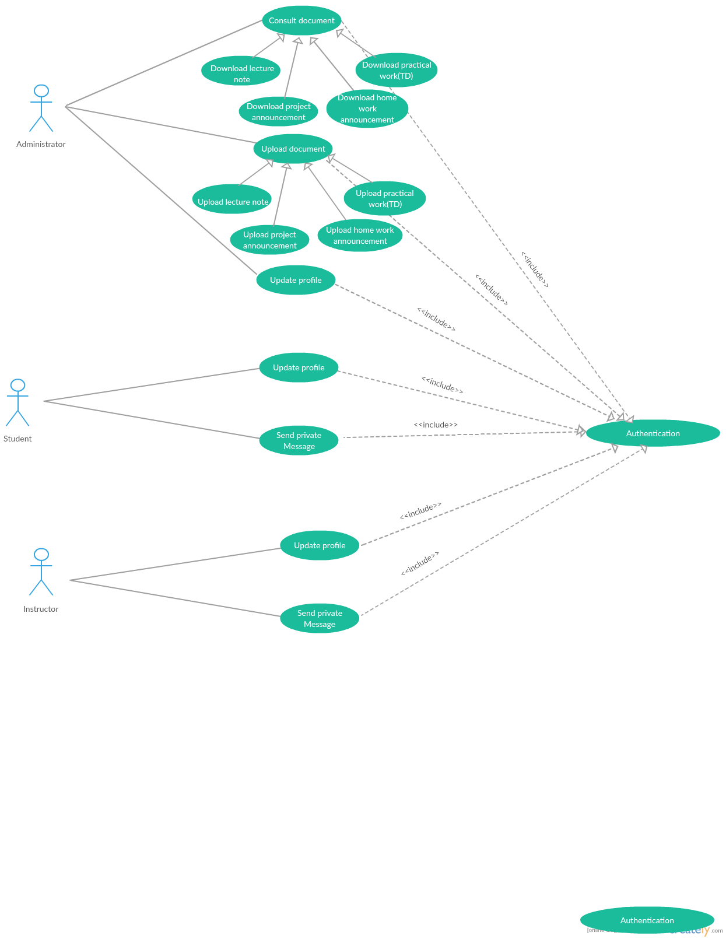

***Figure: Use cases diagram of low priority after refinement***

1. **Technical analysis**

After refining use cases of low priority, we will move on to technical analysis.

In the following we will present the class and sequences diagrams associated to each use case and model their interfaces and their controllers.

1. **Analysis of the use case *Update profile***

In order to model the use case “*Update profile”*. in first order, we used a class diagram which presents one interfaces, one controllers and one entity class, to illustrate the interaction between them we will present a detailed sequence diagram.

1. **Class diagram of the use case *Update profile***

The following figure presents the class diagram of the use case *Update profile*

**

**Figure: Class diagram of the use case *Update profile***

1. **Sequence diagram of the use case *Update profile***

The following figure presents the sequence diagram of the use case *Update profile*



**Figure: Sequence diagram of the use case *Update profile***

1. **Analysis of the use case *Send private message***

In order to model the use case “*Send private message”*. in first order, we used a class diagram which presents one interfaces, one controllers and one entity class, to illustrate the interaction between them we will present a detailed sequence diagram.

1. **Class diagram of the use case *Send private message***

The following figure presents the class diagram of the use case *Send private message*

**

**Figure: Class diagram of the use case *Send private message***

1. **Sequence diagram of the use case *Send private message***

The following figure presents the sequence diagram of the child *Accept attendance letter request*



**Figure: Sequence diagram of the use case *Send private message***

1. **Graphical analysis**

The graphical analysis describes the interface of the project to attract attention and to find the information via visual contents (images, colors, text, shapes...). Indeed, this part allows the user to better understand the website.

1. Synopsis

* Subject

It is a platform that allows the users to manage several activities such as sharing sources, requesting assignments and turn it in assignments in which it is possible to check plagiarism, sharing quizzes, sending e-mail and more.

This project is to develop a website for university (ISAMM) entitled "ISAMMDOCs".

* Support

International network: internet

* Support type

Dynamic website.

* Target audience

This website targets to the administration, instructors and students of ISAMM.

1. Graphical charter

The graphical charter makes it possible to maintain a graphical consistency in the realization of a project.

* Colors
* Colors occupy a very important place in the symbolic, since it is the first message perceived by Internet users.
* We fixed our choice of colors on the light blue and the dark blue.
* **Light blue** is associated with health, healing, tranquility, understanding, and softness.
* **Dark blue** represents knowledge, power, integrity, and seriousness.

The colors used in the graphical chart as well as their HTML codes:

* Light blue: #3BADF5
* Dark blue: #012340
* Light gray: #D4D4D4

* Shapes

Using shapes can be an interesting way to add meaning or create new visual interest in a design project. As with any other type of effect, be aware of using too many shapes at once.

In our website, we concentrated to use squares and rectangles because they are the default shape for most projects for a reason. This common shape creates a sense of equality and conformity. The familiar shape is seen as stable and trusting. The square further relates to the earth, with each of the four corners relating to the four points on a compass.

* Typography

The typography used in our website can convey many emotions, like using bold to embellish a point, using all capital letters to convey shouting, or using italics to give background information.

1. Visual identity analysis

* Logotype

The logo is essential for the visual identity of our website which is characterized by the logo of ISAMM institute.

Figure below presents the logo of ISAMM institute



Figure : Official logo of ISAMM Institute

* Scenario model

The scenario model is the culmination of a long reflection process carried out step by step.

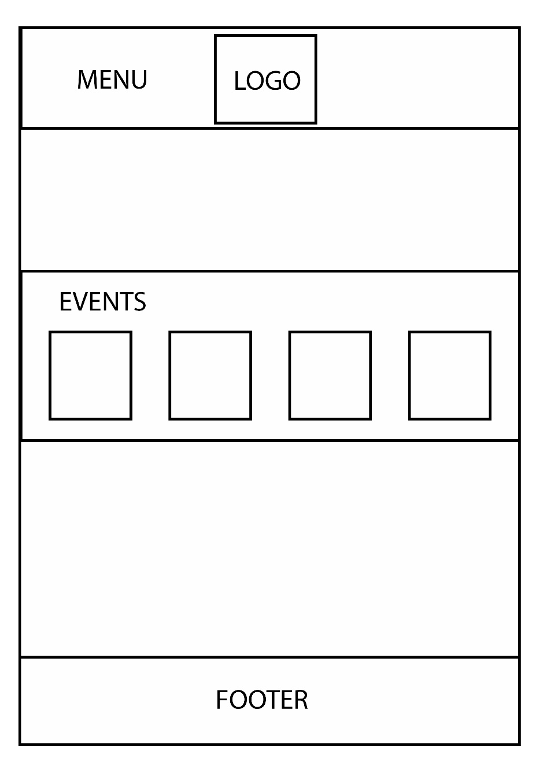A model is a prototype website presenting the webpage navigation. It makes it possible to formalize the design in a better way.

Figure: First proposal of the model

Comment: A simple proposal. The events are well highlighting in the page but we see that there is a lot of vacuum.

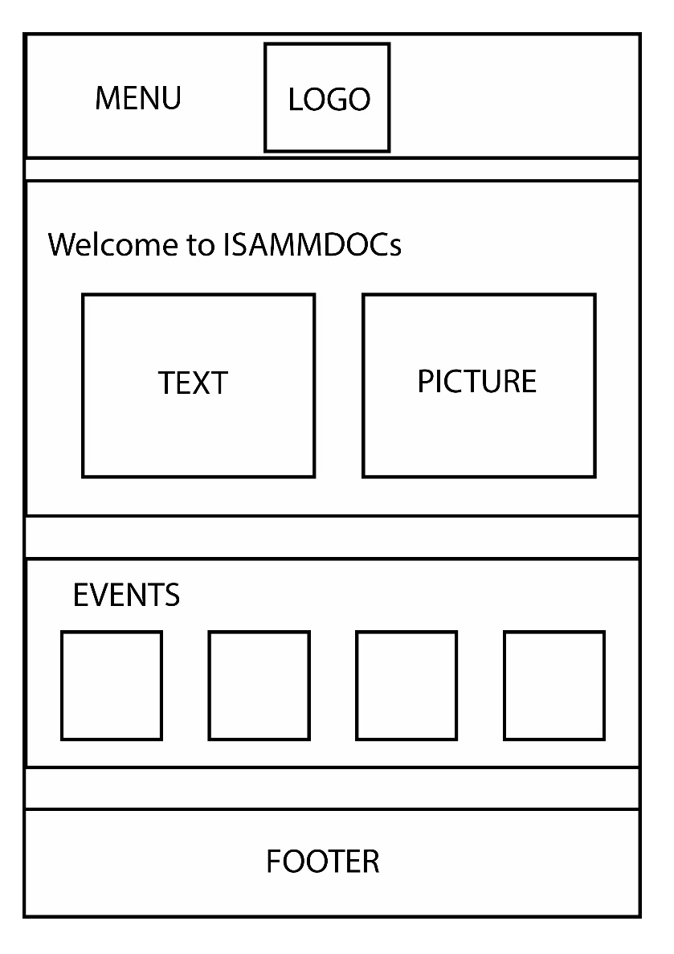

Figure: Second proposal of the model

Comment: By adding the website description, the page is much more interesting.

Indeed, the part of the text and the picture occupied the vacuum which it had in the preceding proposition. But the header seems like did not highlight the logo.

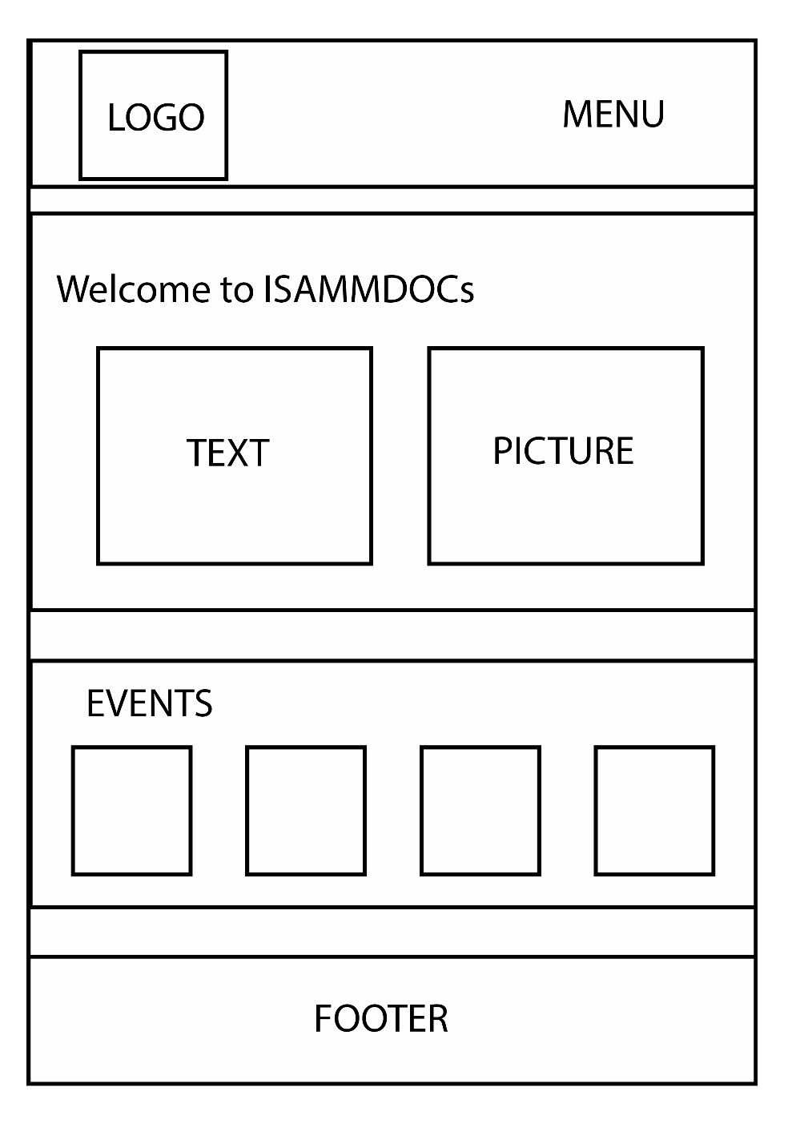Figure: Final proposal of the model

Comment: The logo is placed in the left of the header, which highlights it better. The description and the events list are well placed in the body of the page. The page has become more ergonomic.

1. **Conclusion**

The construction phase described the refinement of low priority use cases, the graphical analysis and the prototype of user interfaces to show some interfaces of the website.

The next chapter consist of tests and implementation phase.

**CHAPTER 5: TRANSITION PHASE**

1. Introduction
2. Work environment
3. Implementation
4. Conclusion

**CHAPTER 5: TRANSITION PHASE**

1. **Introduction**

After completing the analysis part, we have moved on to the realization phase. The first part will describe our work environment. Afterwards, we will present the implementation of the website attached to screenshots.

1. **Work environment**

We will present the hardware and software configuration available to us to ensure the project's progress

1. **Hardware configuration**

We used as hardware, two laptops with the following features:

|  |  |
| --- | --- |
| **Asus ZenBook UX310UQ** | |
| **CPU** | Intel Core i7-6500U |
| **GPU** | Nvidia GeForce 940MX |
| **RAM** | 8 GB |
| **HARD DRIVE** | 1TB |
| **SCREEN** | 13.3**”** |

Tableau: Hardware used for the website creation

1. **Software configuration**

* **Operating system:** Windows 10.
* **Adobe Photoshop:** As a photo editor [URL 7].
* **Sublime Text 3:** As a text editor [URL 8].
* **WampServer:** As web development environment. It allows you to create web applications [URL 9].
* **Php MyAdmin:** As a database manager [URL 9].
* **Creately:** As a UML (Use case diagrams) drawer [URL 10].
* **PowerAMC:** As a UML (class and sequence diagrams) drawer.

1. **Programming language**

* **HTML (Hyper Text Markup Language):** Standard markup language for creating Web pages [URL 1].
* **CSS (Cascading Style Sheets**)**:** Stylesheet language used to describe the presentation of a document written in HTML [URL 2].
* **PHP (Hypertext Preprocessor):** Open source general-purpose scripting language that is especially suited for web development and can be embedded into HTML [URL 3].
* **BOOTSTRAP:** Bootstrap is the most popular HTML, CSS, and JS framework for developing responsive, mobile first projects on the web [URL 4].
* **UIKIT:** A lightweight and modular front-end framework for developing fast and powerful web interfaces [URL 5].
* **JS (Java Script):** Full-fledged dynamic programming language that, when applied to an HTML document, can provide dynamic interactivity on websites [URL 6].
* **AJAX (*Asynchronous JavaScript and XML)*:** Web applications can send data to and retrieve from a server asynchronously (in the background) without interfering with the display and behavior of the existing page [URL 11].

1. **Implementation**

In this part, we will present the final user interfaces of the website ISAMMDOCs

1. **Index page before Log In**

The first model represents the home page of the website before logging in, in which are displayed a brief description of ISAMMDOCs followed by the incoming events.

Model 2: Interface of homepage before logging in

1. **Log In**

The model below shows the interface of login which the user needs to insert the national ID number as and the registration number as password.

Model 2: Interface of Log In

1. **Index page after Log in**

The third model represents the home page of the website after logging in.

In the followed model, we logged in as administrator.

Model 3: Interface of homepage after logging in

1. **Members (Specific for the administrator)**
2. **Add new member**

The model below shows the interface of adding new member.

Model 4: Interface of Add new member

1. **List of members**

The model represents the Members interface which is displayed the list of all the members sorted by the roles.

Model 5: Interface of Members

1. **Courses**
2. **Add new course**

The model below shows the interface of adding new course.

Model 6: Interface of Add new member

1. **Add new document**

The model below shows the interface of adding new document in specific course.

Model 7: Interface of Add new document

1. **Add new discussion topic**

The model below shows the interface of adding new discussion topic in specific course.

Model 8: Interface of Add new discussion topic

1. **Submit homework**

The model below shows the interface of Submitting homework in specific course.

Model 9: Interface of Submit homework

1. **Attendance**

The model below shows the interface of doing the attendance in specific course.

Model 10: Interface of Attendance

1. **Update homework grade**

The model below shows the interface of doing the updating homework grade in specific course.

Model 11: Interface of Update homework grade

1. **News**
2. **Events**
3. **Conclusion**

**In this last chapter, we have presented the hardware and software environment of the work, as well as the implementation which**

**present the different screenshots of the interfaces of the platform.**

**Conclusion and Perspectives**

Throughout the period of this internship, which was aimed to the realization of a platform that ameliorate the relation between the students, instructor and administration in the university using the technology.

The development of this project within the company "ArzenSystems" has proved to be a very beneficial experience, both on a personal, human and technical level for several reasons.

First, we had the opportunity to work into a team during the development of this project. This allowed us to integrate ourselves into a professional working environment. Secondly, this experience enabled us to put into practice the knowledge acquired during our education period.

Our project evolved in an iterative and incremental manner at the same time. Indeed, it went through several phases.

We have used RUP methodology to organize our report so we have sorted our use cases by priorities to facilitate our tasks. We started with project overview. Afterwards, we analyzed the existent similar application which enabled us to identify the actors as well as the functional and nonfunctional requirements and draw up the global use cases diagram. Once completed, we have chained by the refinements of these cases and their technical and graphical analysis.

Finally, we presented our work environment and we implemented our project with screenshots showing user interfaces of different properties.

However, this project does not claim perfection, it deserves some improvements. considering the use of the Rational Unified Process (RUP) where it is an iterative software development, improving and maintaining the project would be an easy problem to solve.

Indeed, this work will be extended and improved by the addition of two languages French and Arabic and implement mobile application.

**Used links**

**[URL 1]:** <https://www.w3schools.com/html/html_intro.asp>

**[URL 2]:** <https://developer.mozilla.org/en-US/docs/Web/CSS>

**[URL 3]:** <http://php.net/manual/en/intro-whatis.php>

**[URL 4]:** <http://getbootstrap.com/>

**[URL 5]:** <https://getuikit.com/>

**[URL 6]:** <https://developer.mozilla.org/en-US/docs/Learn/Getting_started_with_the_web/JavaScript_basics>

**[URL 7]:** <https://itconnect.uw.edu/learn/workshops/online-tutorials/graphics-and-design-workshops/adobe-cs/photoshop/>

**[URL 8]:** <https://sublimetext.com/>

**[URL 9]:** <http://www.wampserver.com/en/>

**[URL 10]:** <https://creately.com/Draw-UML-and-Class-Diagrams-Online>

**[URL 11]:** <https://en.wikipedia.org/wiki/Ajax_(programming)>